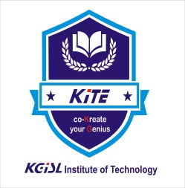


KGISL INSTITUTE OF TECHNOLOGY
(Approved By AICTE, Affiliated to Anna University, Chennai)
# 365, KGiSL Campus, Thudiyalur Road, Saravanampatti, Coimbatore-641035

DEPARTMENT OF NATIONAL CADET CORPS

ANNUAL REPORT
2021 - 2022

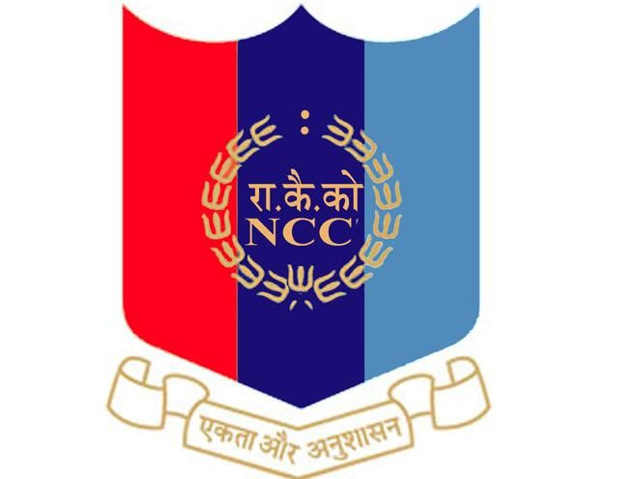

4 TAMIL NADU BATALLIAN NCC, COIMBATORE

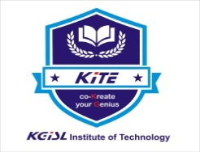

KGISL INSTITUTE OF TECHNOLOGY
(Approved By AICTE, Affiliated to Anna University, Chennai)
# 365, KGiSL Campus, Thudiyalur Road, Saravanampatti, Coimbatore-641035

NCC INAUGURAL

The new rising of 04 (TN) National Cadet Corps (NCC) Sub-unit (Army SD/SW) has been inaugurated at KGiSL Institute of Technology, Coimbatore on 25.11.2021. The Chief Guest Col JPS Chauhan, Commanding Officer, 4 (TN) BN NCC, Coimbatore has hoisted the National and NCC Flags at 11. 45 AM in KGiSL Campus ground. All the participants saluted the National and NCC flag.

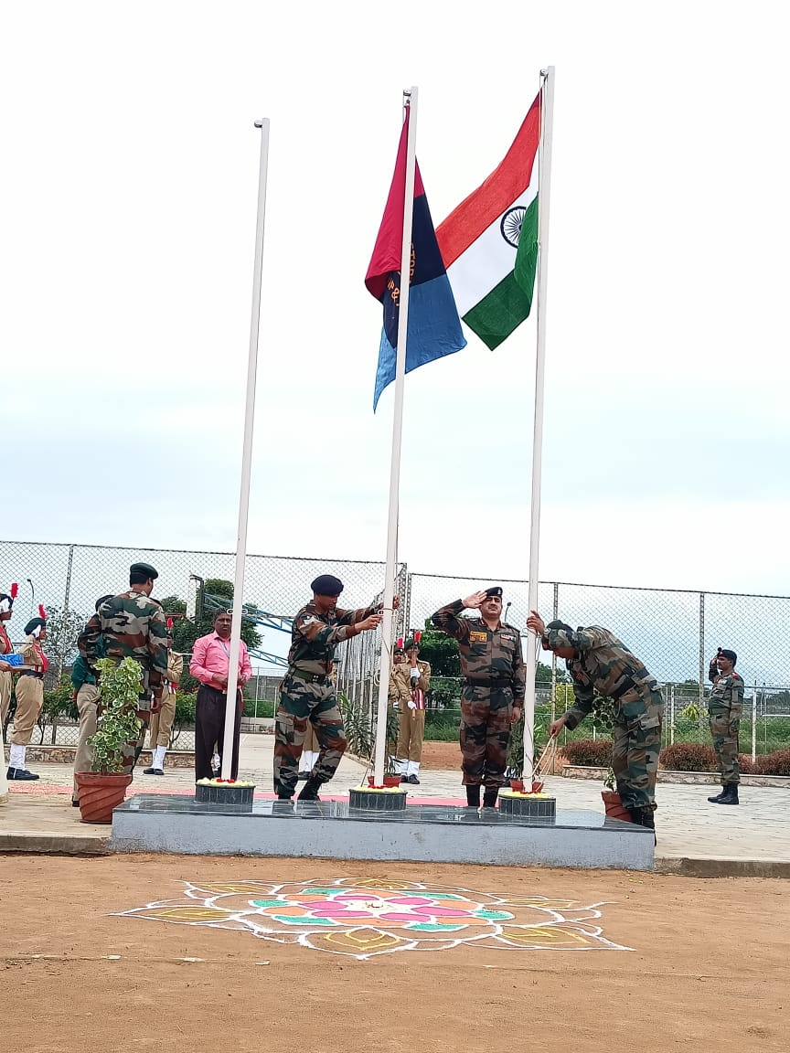
Dr. M. Selvam, Principal, Dr. N. Rajkumar, Secretory, with the Chief Guest Col JPS Chauhan, Commanding Officer, 04 (TN) NCC, Coimbatore, during the NCC Flag hoisting
After flag hoisting, Col JPS Chauhan cut the ribbon and opened new NCC room. Principal Dr. M. Selvam welcomed the gathering. In his welcome address, he emphasized the need of joining in NCC through which students can render their service as responsible citizen. The chief guest encouraged the students with his invigorating speech. In his speech he said NCC aims to develop qualities of character, courage, comradeship, discipline, leadership and secular outlook, the spirit of adventure and sportsmanship and ideals of selfless service among the youth to make them useful citizens. The keynote address was given by our Secretary Dr. N. Rajkumar. In his address, he said, “Even though the NCC was initially created as a second line of defence for the nation, the NCC experience is much more than that. It is a platform to build character, team work, leadership qualities and a secular outlook in life. Finally, the vote of thanks was proposed by Ms B. Monika, I-Year Student.

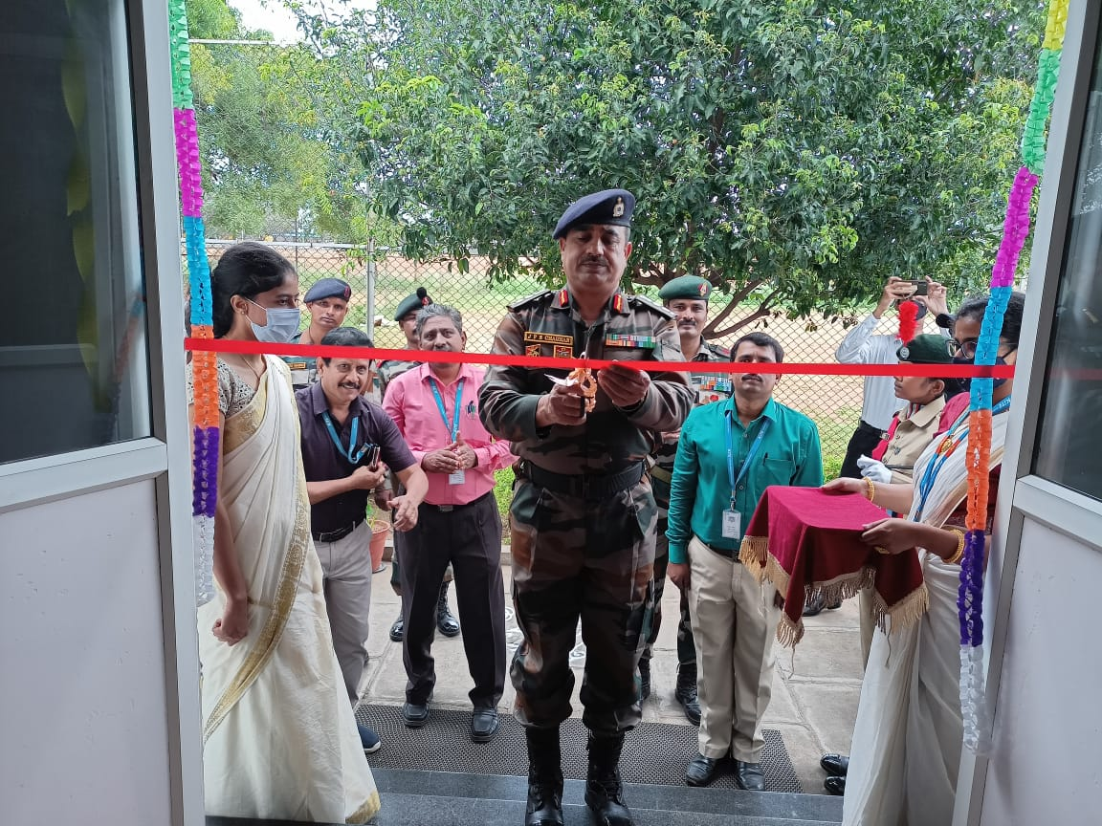
Dr. M. Selvam, Principal, Dr. N. Rajkumar, Secretory, with the Chief Guest Col JPS Chauhan, Commanding Officer, 04 (TN) NCC, Coimbatore, during NCC room opening.

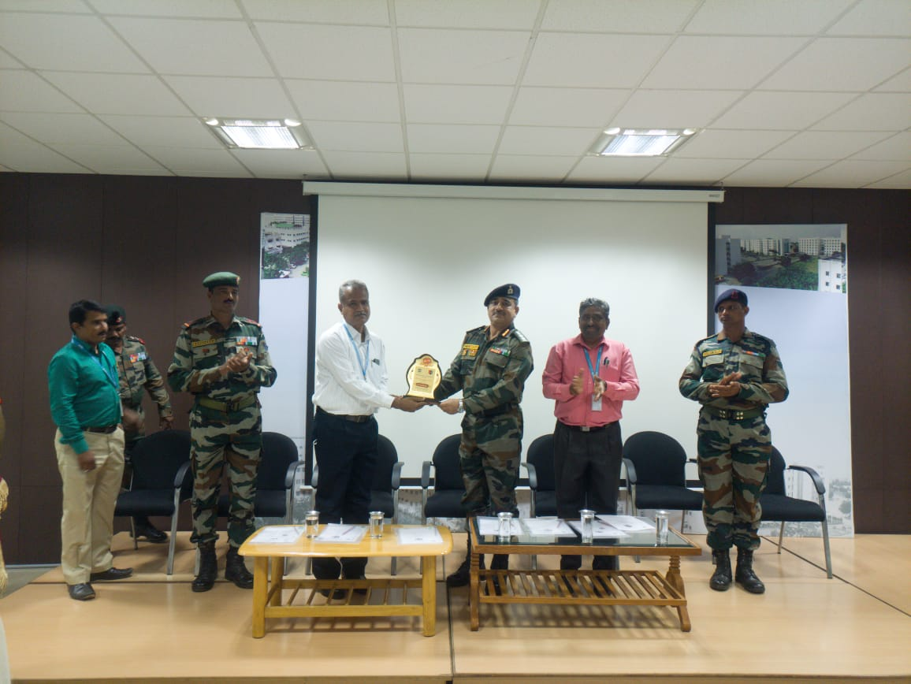
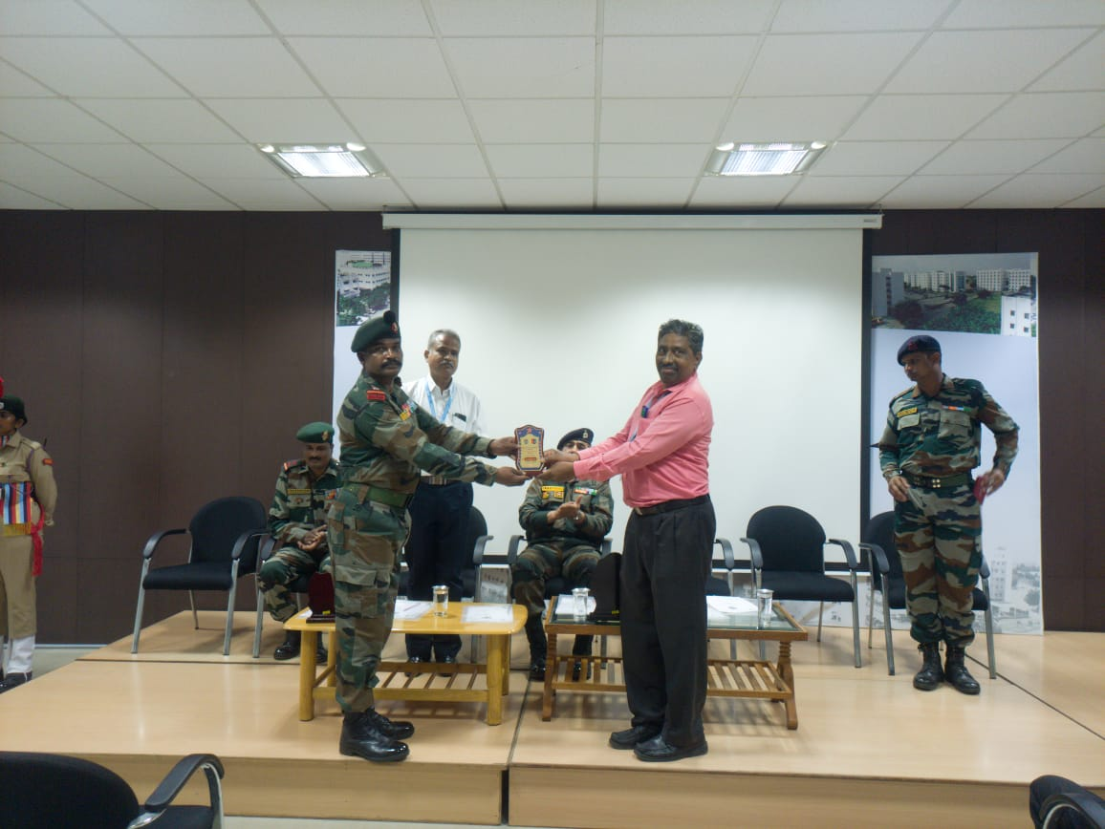
Dr. M. Selvam, Principal, Dr. N. Rajkumar, Secretory, with the Chief Guest Col JPS Chauhan, Commanding Officer, 04 (TN) NCC, Coimbatore, during New rising inauguration event held on 25th November 2021.

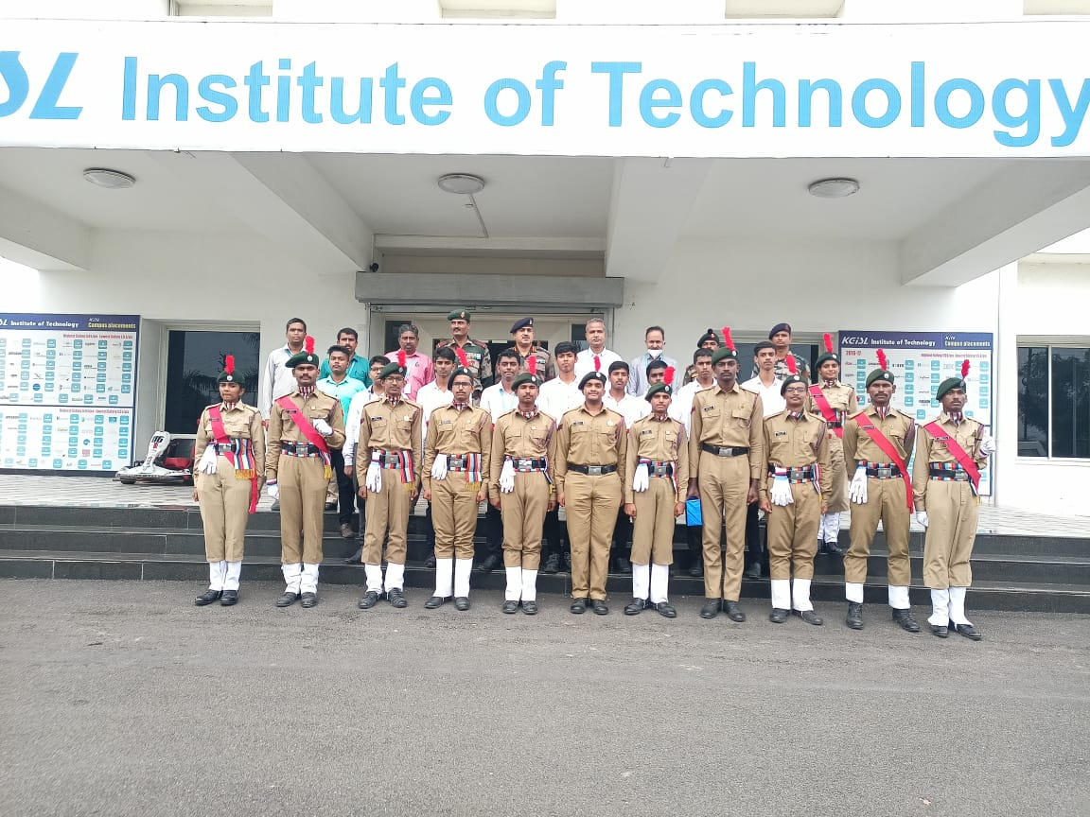
NCC Inaugural Function Group Photo

NCC DAY
The NCC Day was celebrated in our college through YouTube for motivate NCC cadets to join the Indian Army, Navy and Air Force.
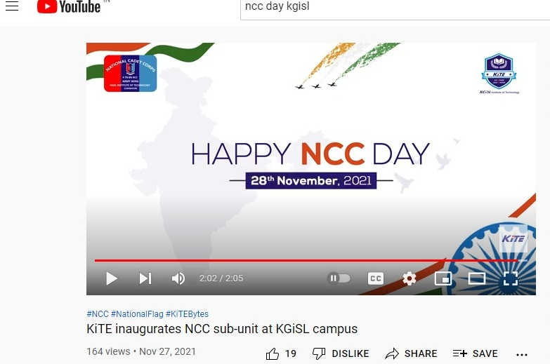
ENROLMENT
The notice was displayed on board for enrolment of the academic year 2021- 22 on 27-11-2021 & 29-11-2021. As per directions from Col JPS Chauhan, Commanding Officer, 04 (TN) NCC, Coimbatore, both Boys and Girls are will enrolled for first year NCC. Fifty One (51) students of various classes were given the enrolment tests and on their performance basis Sixteen (16) students were enrolled in the first year NCC and One (01) boy cadet, who passed the certificate ‘B’, were enrolled in third year NCC.

THE KOUSIKA RIVER REJUVENATION PROJECT-TREE PLANTATION
The National Cadet Corps has planted over 150 saplings the Kousika River Rejuvenation Project during the tree plantation drive on 19-12-2021.
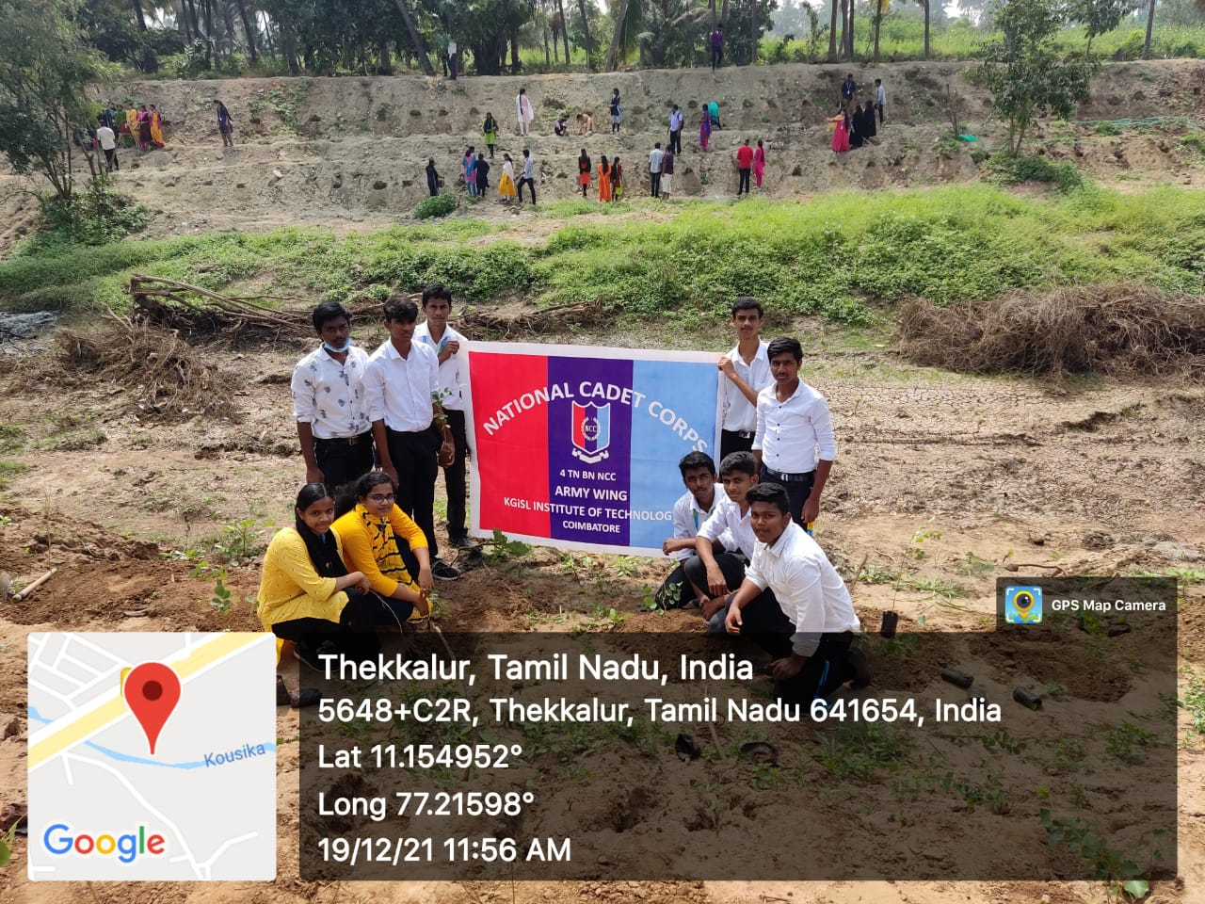

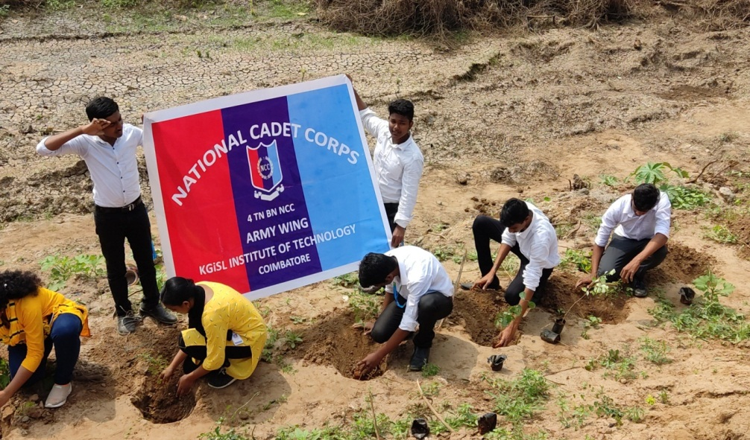

SPECIAL CLASS FOR “B” & “C” CERTIFICATE EXAM
Our college 17 cadets are attended the special class and got the knowledge of “B” and “C” Certificate Exam at Kumaraguru College of Technology, Coimbatore on 16.12.202.
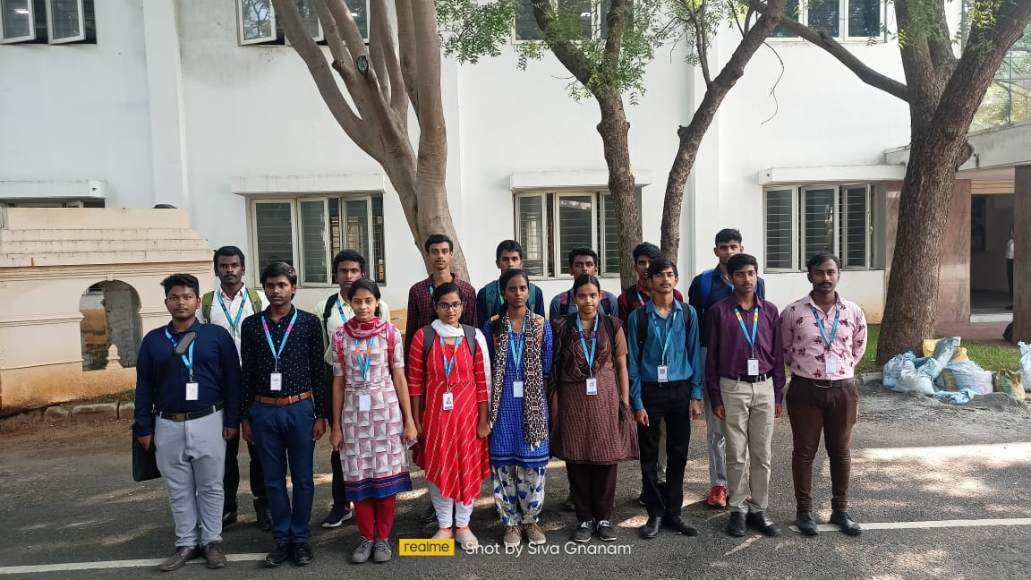
ANNUAL TRAINING CAMP
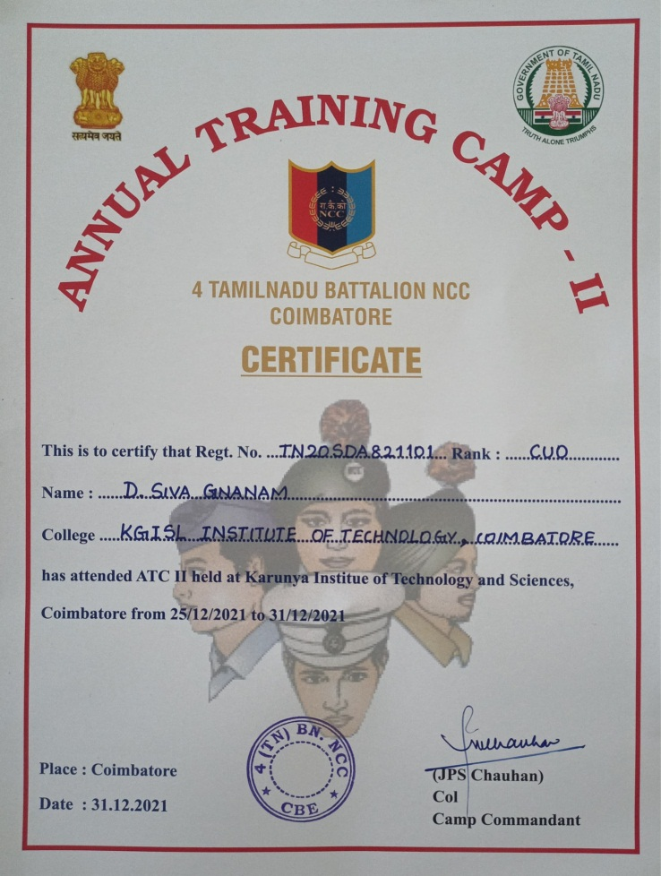
Our college, One (01) cadet was attended the special class and got the knowledge of C” Certificate Exam at Karunya Institute of Technology and Science, Coimbatore from 25.12.2021 to 31.12.2021.

REPUBLIC DAY 26 JANUARY 2022
The day was celebrated in our college with great eclat. The college ground was tastefully decorated by the NCC cadets. It was a proud moment to be a part of NCC. Arrived at the college in NCC uniform at 7:00 AM. The first mission was to clean up the college and its surroundings. We performed our duty in accordance with the Covid protocol. There was a Republic Day flag off that included our Principal, Secretary, All HODs, PDs and Dr. S. Vimal Kumar / CTO-NCC. We looked at the rising flag and saluted it with full hope.
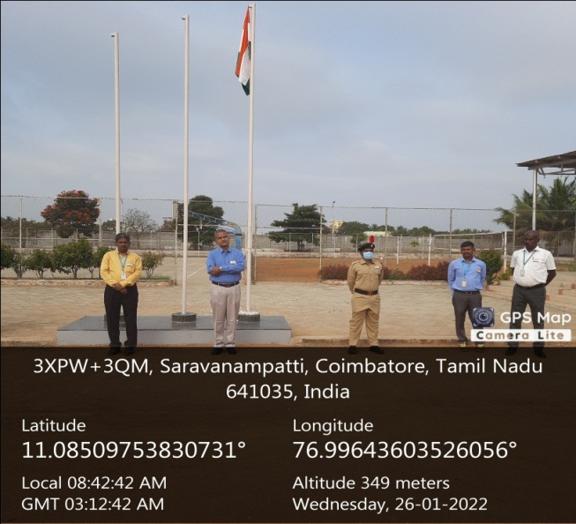
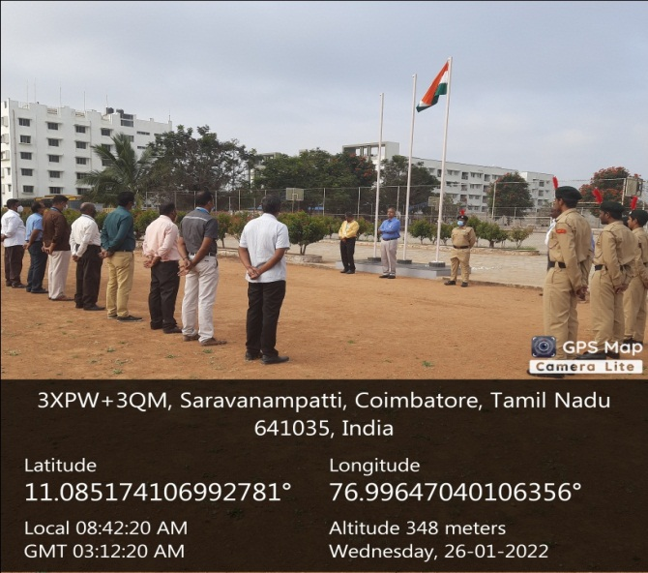

SURYA SHAKTHI YOGA
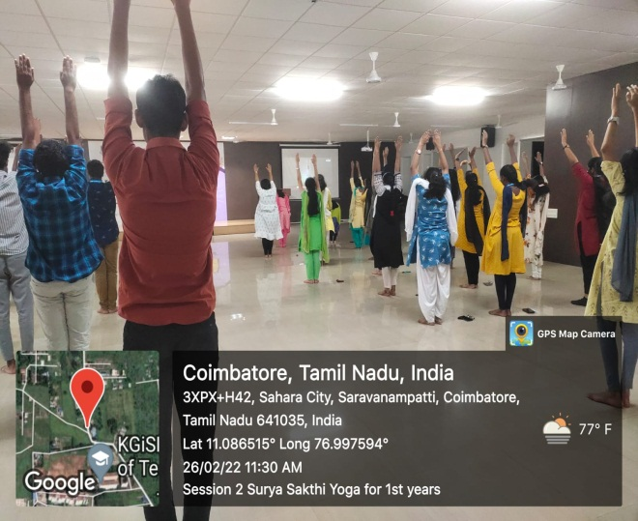
On 26 Feb 2022, 10 KITE NCC cadets had participated in the offline event of Surya Shakthi Yoga organized by the Isha Yoga foundation, Coimbatore.
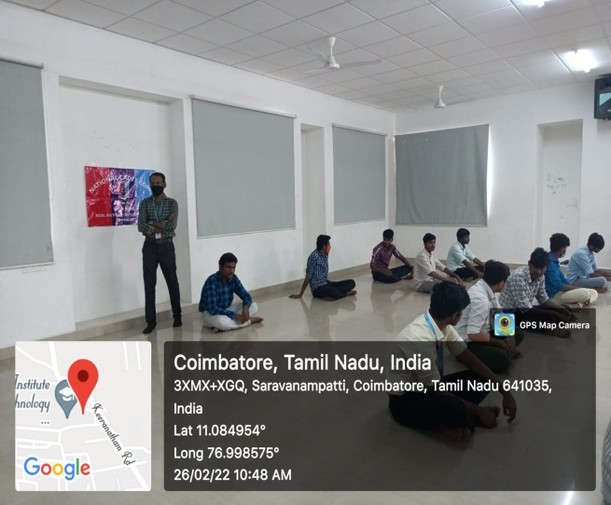

RIFLE SHOOTING COMPETITION
Our college, Four (04) NCC cadets to participate in the NCC Shooting Competition at Karunya Institute of Technology and Science. Our college, one cadet (MUTHAIAH G ) have done well in this shooting competition and selected up to in third round.
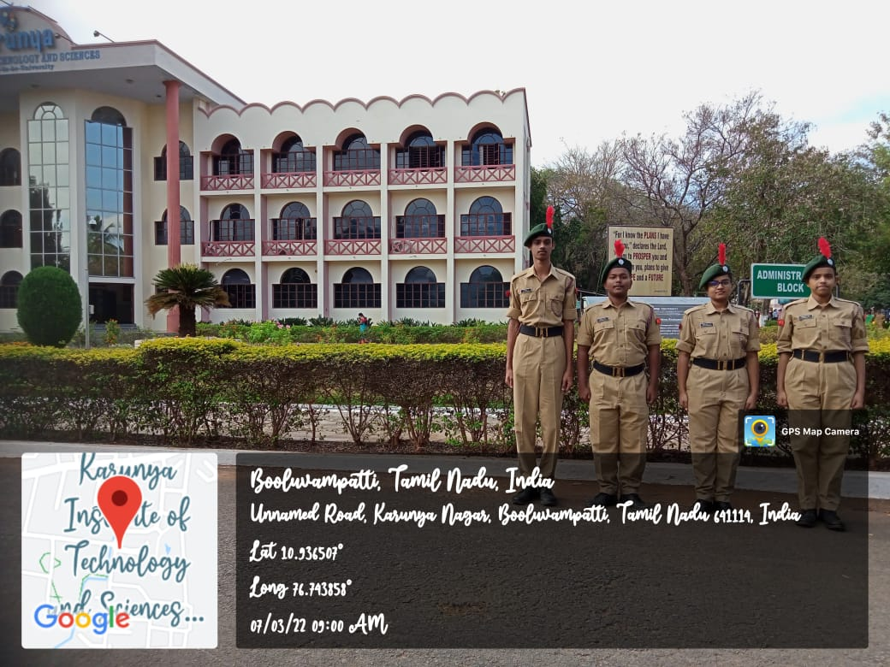

SPECIAL CLASS FOR “C” CERTIFICATE EXAM
Our KITE, One cadet attended the special class and got the knowledge of “C” Certificate Exam from 26.03.2022 & 27.03.2022 and our college CTO-NCC handled the theory class at Kumaraguru College of Technology, Coimbatore on 27.03.2022.
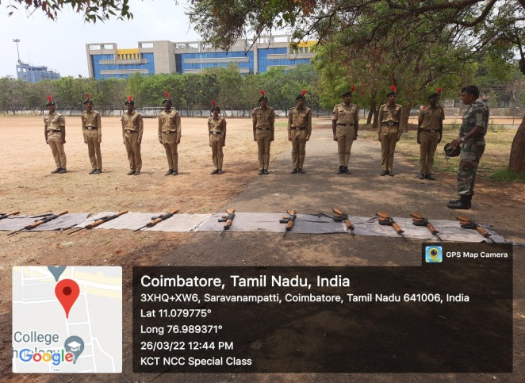
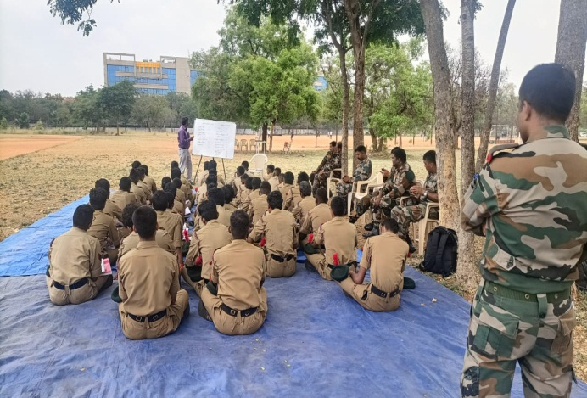

PUNEET SAGAR ABHIYAN
In keeping with the vision of Prime Minister Shri Narendra Modi, National Cadet Corps (NCC) has initiated a nationwide flagship campaign ‘Puneet Sagar Abhiyan’ to clean seashores/beaches and other water bodies, including rivers and lakes of plastic & other waste material. The initial phase of the ‘Puneet Sagar Abhiyan 2022’ is being conducted in a grand manner between April 01-05, 2022, coinciding with the National Maritime Day. More than 1.5 lakh cadets from all 17 State Directorates of the NCC are participating in various activities, positively impacting a population of approximately 50 Lakh citizens.
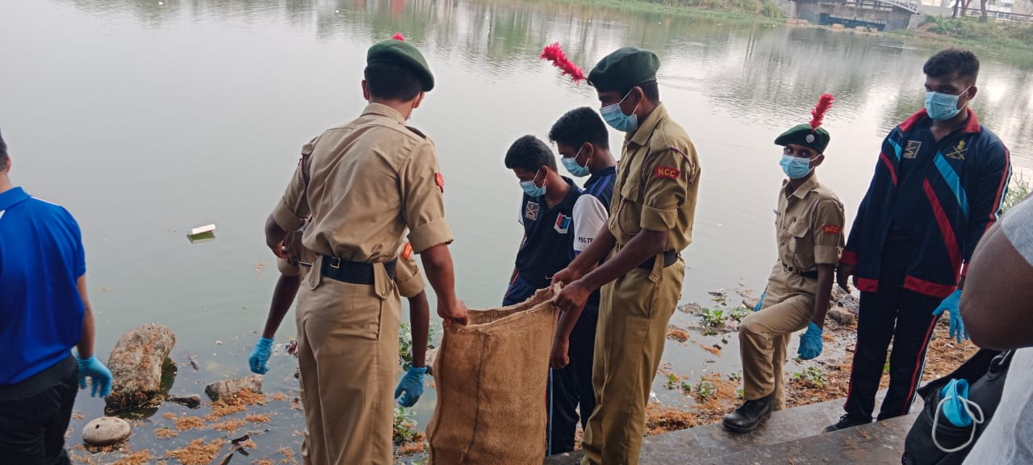
On 01 April 2022, 5 KITE NCC cadets had participated with enthusiasm and vigour in cleaning up the plastic waste at Ukkadam-Valankulam Lake, Coimbatore.
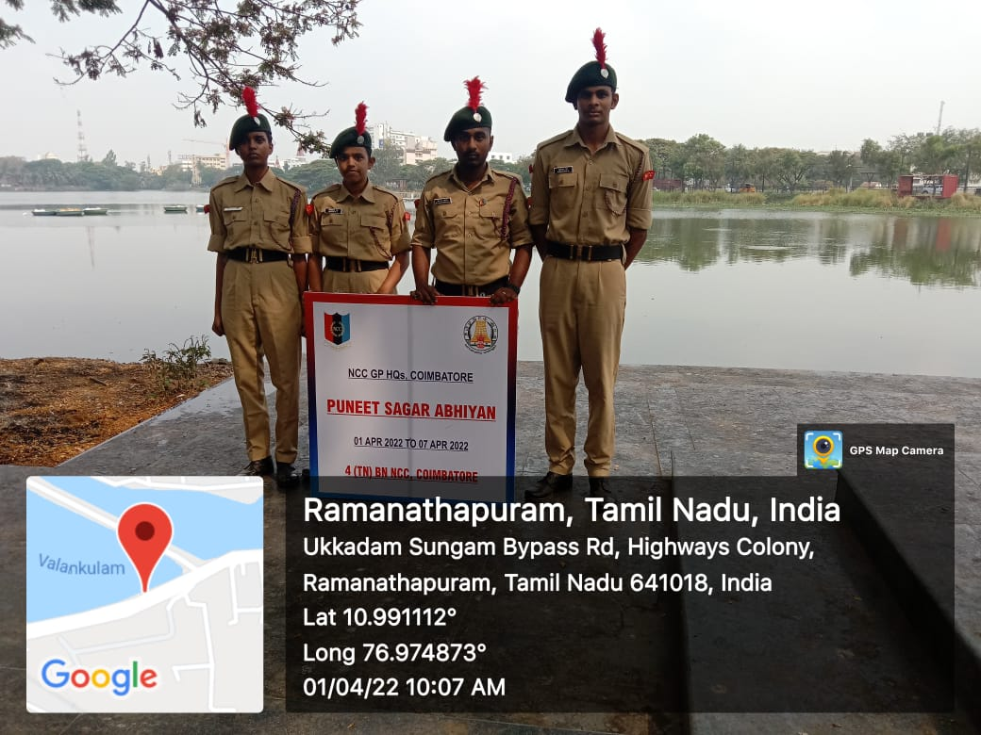

KITE SPORTS DAY
NCC cadets are participated KITE Sports Day on 28 Apr 2022.
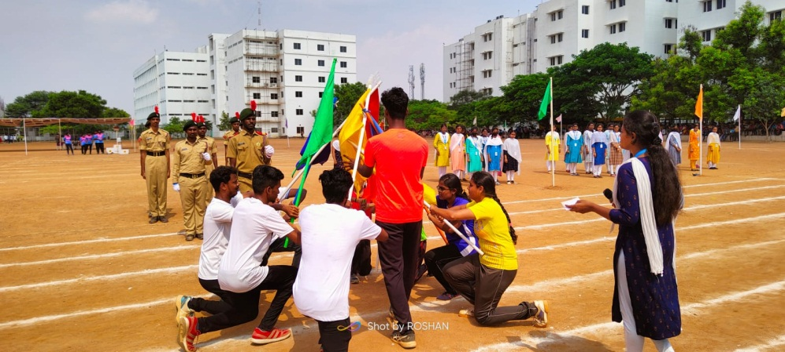

THAL SAINIK CAMP (TSC)
Our college, Four (04) NCC cadets participated in the TSC selection at PSG College of Arts & Science, Coimbatore on 28 Apr 2022.
One cadet (MONIKA B) was selected in main team and one cadet (AUXSHILIA S) was selected in waiting list.
Sri Seshaas International Public School, Salem
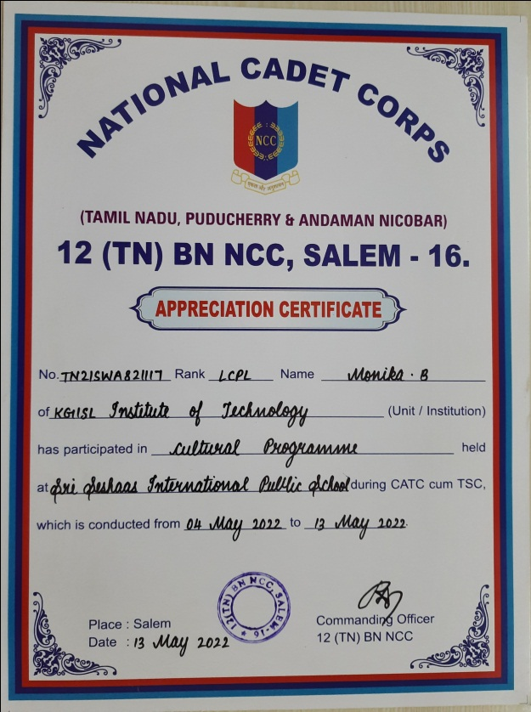
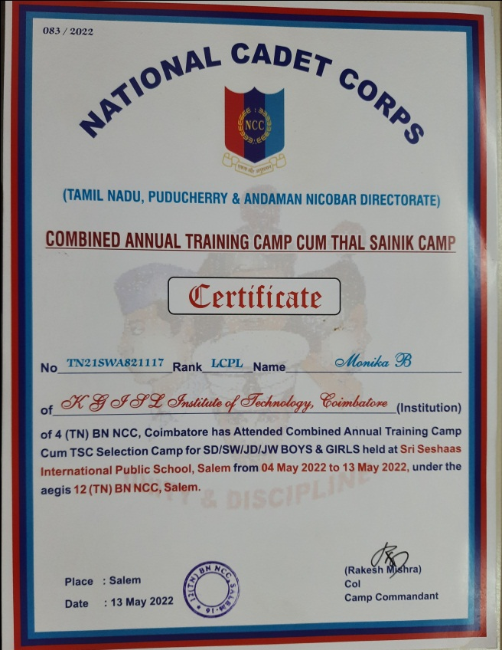

KSR College of Engineering, Tiruchengode
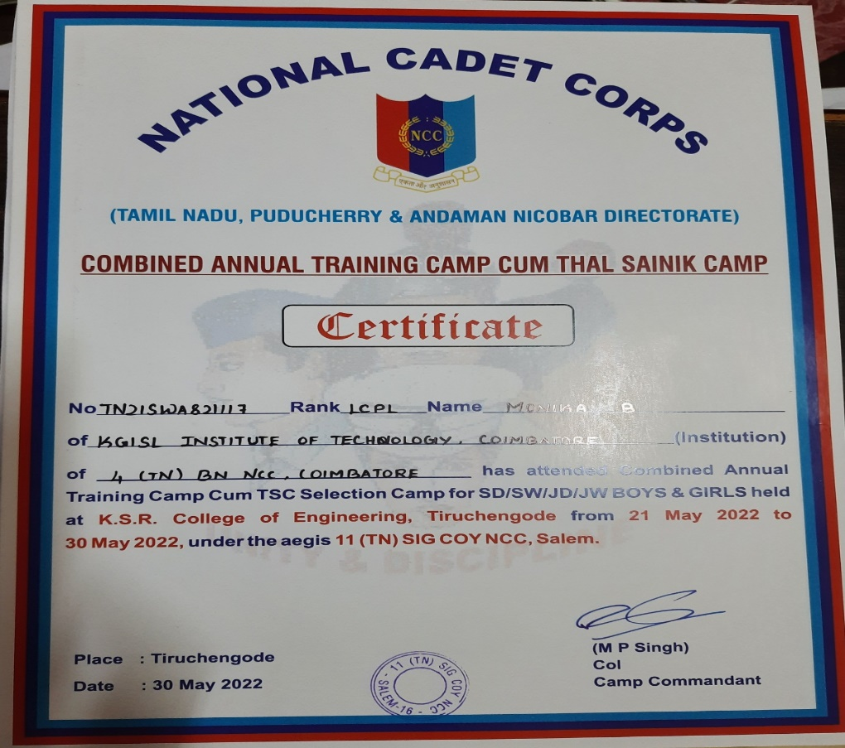

NCC CLASS & DRILL
