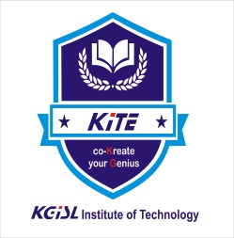


KGISL INSTITUTE OF TECHNOLOGY
(Approved By AICTE, Affiliated to Anna University, Chennai)
# 365, KGiSL Campus, Thudiyalur Road, Saravanampatti, Coimbatore-641035

NATIONAL CADET CORPS (NCC)

ANNUAL REPORT
2023 - 2024

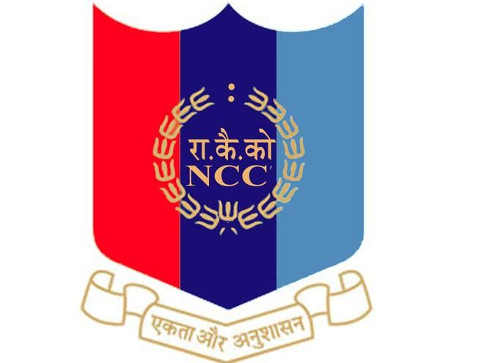

4 TAMIL NADU BATALLIAN NCC, COIMBATORE
SWACHHTA ABHIYAN - PLASTIC WASTE MANAGEMENT AND SAY NO TO PLASTIC on 10.05.23
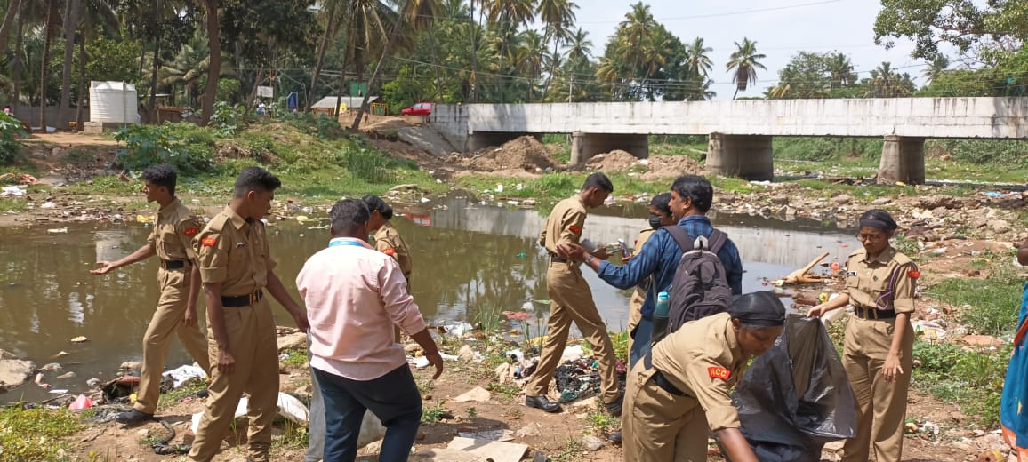
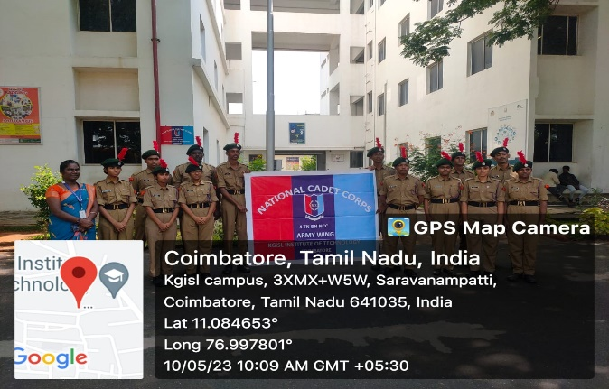
KITE NCC is organizing a Swachhta Abhiyan (Plastic Waste Management and Say No to Plastic) on May 10, 2023 at Perur Noyal River. The aim of the programme The Swachhta Abhiyan on Plastic Waste Management and Say No to Plastic created significant awareness among cadets and the local community about the harmful effects of plastic pollution. Cadets are gained practical knowledge on the importance of proper plastic waste segregation, recycling, and the need to reduce single-use plastic consumption. The campaign promoted eco-friendly practices and encouraged behavioral change towards a cleaner and greener environment. The initiative instilled a strong sense of social responsibility and environmental consciousness among the participants, aligning with the broader goals of sustainability and Swachh Bharat.
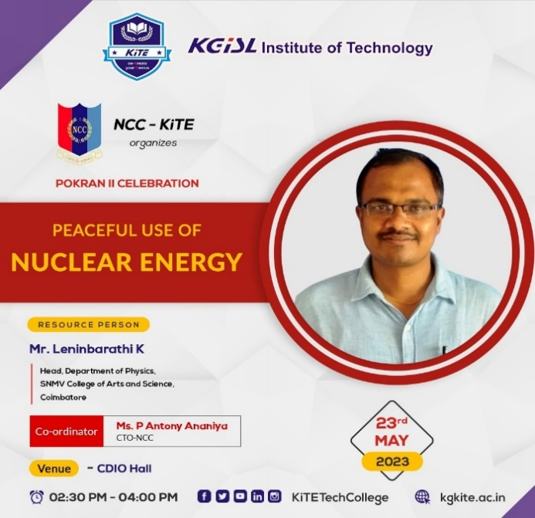
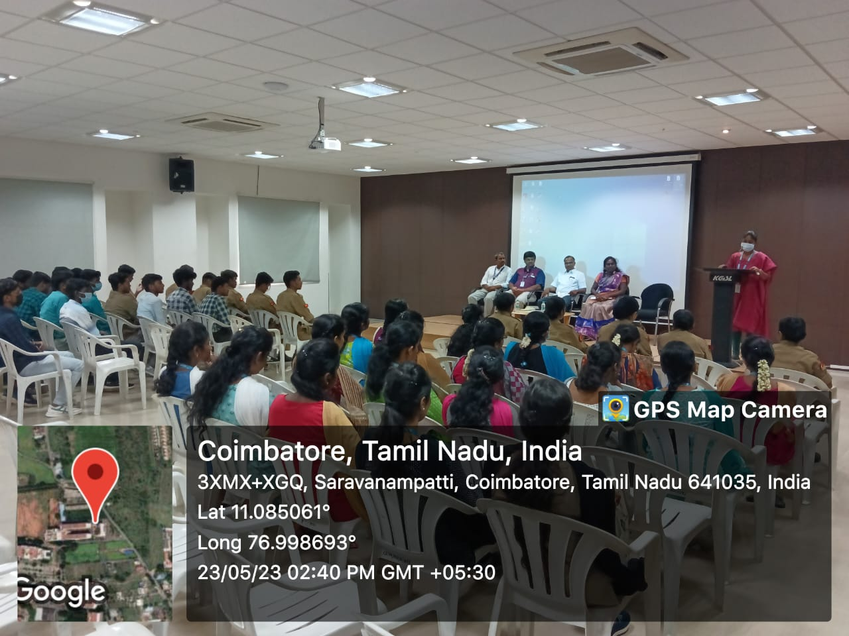
POKRAN II CELEBRATION ON PEACEFUL USE OF NUCLEAR ENERGY on 23.05.23
The NCC KiTE, celebrated the “POKRAN II CELEBRATION” on Peaceful Use Of Nuclear Energy with the objective the celebration was to elaborate on the importance of Nuclear power and How to use in our Day to Day life. The NCC Cadets and students got benefitted for this event. The resource person starts his talk by introducing five Tamil Nadu scientists with their reference books. All authors and scientists should improve their knowledge using Tennessee Scientists. Motivated our cadets and students to encourage reading a book. then introduced the Pokran I and II, and how to prepare the atom and nuclear forces were discussed elaborately.
INDEPENDENCE DAY 15.08.23

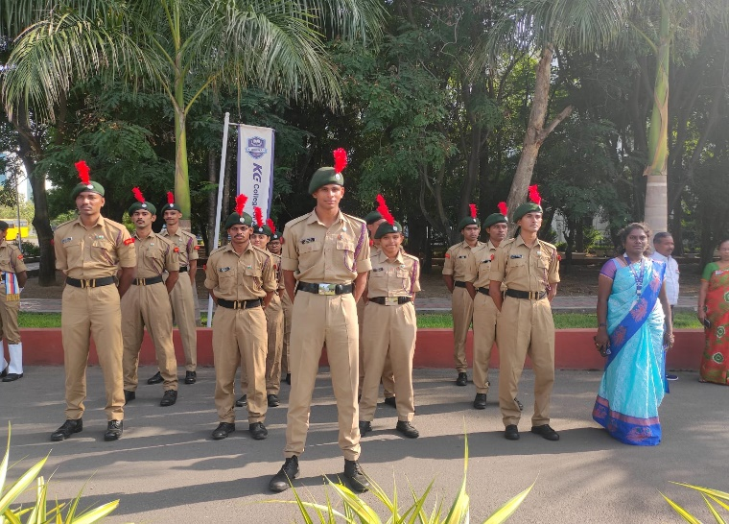
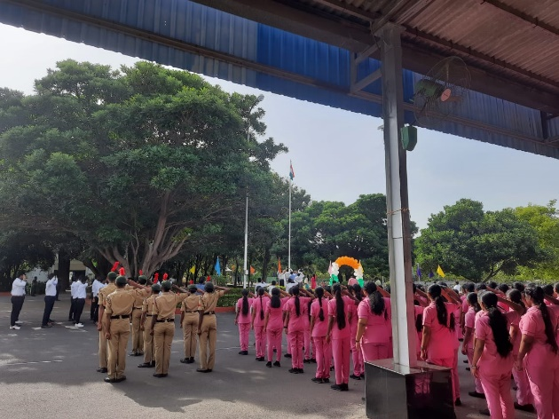
Every year Independence Day celebration is done in our college premises. Being an NCC cadet we must celebrate Independence Day to respect our patriotism. NCC unit of our college plays an important part in Independence Day celebration. NCC cadet have special practice for Independence Day celebration. Piloting for the guests, commanding preparation, band set practices and seniors reporting are the practices done by NCC careers as a preparation of Independence Day.

ENROLMENT on 22.09.23
The notice for NCC enrolment for the academic year 2023–24 was displayed on the notice board on 22.09.2023. As per the directions of Lt. Col. Lalremruata Oinam, Commanding Officer, and Sub. Maj. Pandiyan, 04 (TN) NCC, Coimbatore, both boys and girls from the second year of KITE were considered for first-year NCC enrolment. A total of 74 students from various classes appeared for the enrolment tests, and based on their performance, 28 students were selected and enrolled into the first-year NCC.
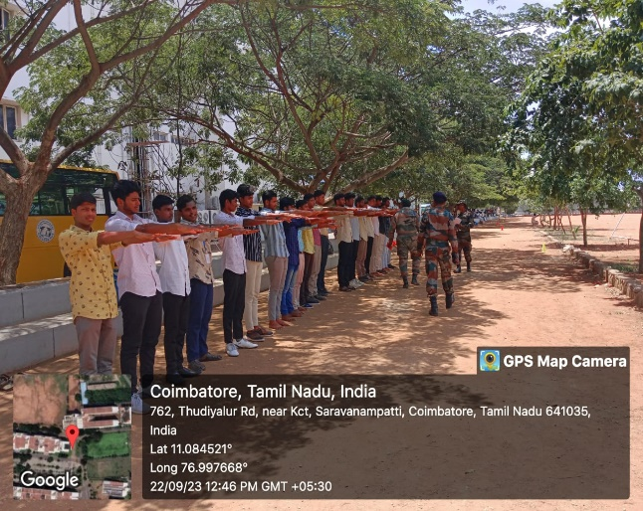
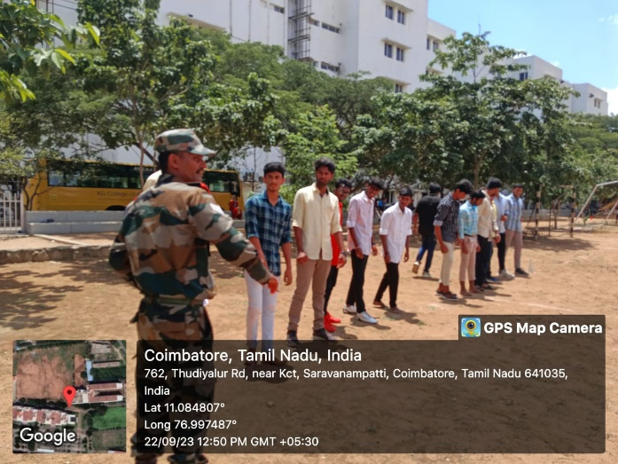
NCC RANK PROMOTION
On November 11, 2023 the rank promotion ceremony for the NCC army wing was conducted, wherein Dr. M. Selvam, Principal, KITE was the chief guest and Mr. D. Manikandan, Administrative Officer-KITE & Ex-Army Officer was special guest. Some of the cadets were promoted to higher ranks for their hard-work, and dedication towards the organisation.
SHOOTING TRAINING on 07.12.23-10.12.23
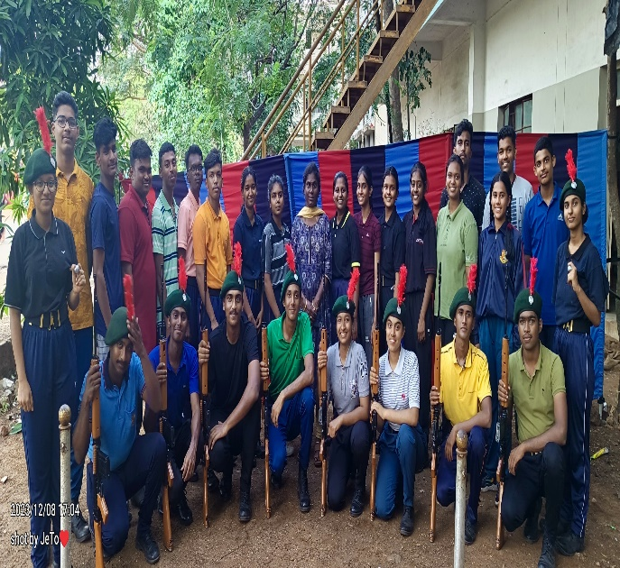
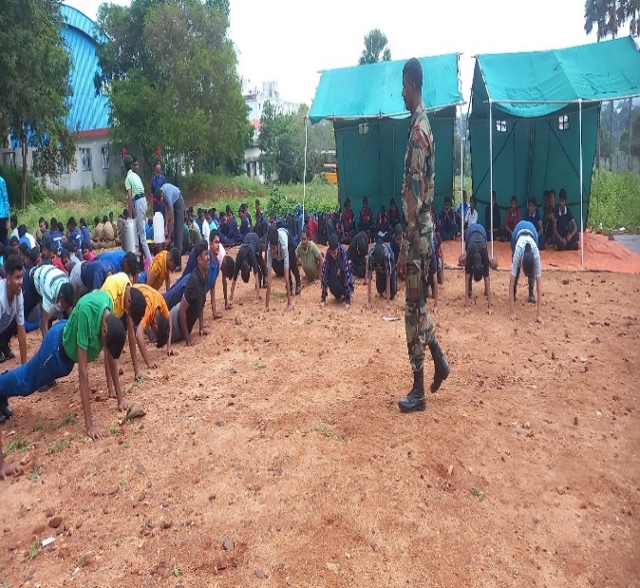
The NCC KiTE, cadets participate the “SHOOTING TRAINING” on 07.12.2023 to 10.12.23 with the objective Enhance the shooting skills of cadets, focusing on precision, accuracy, and consistency in handling firearms. SM sir and CO Sir also talked about his struggle regarding his career and TSC, RD selection to do more hard work.
NAAC Guard of Honour on 13.12.23-14.12.23
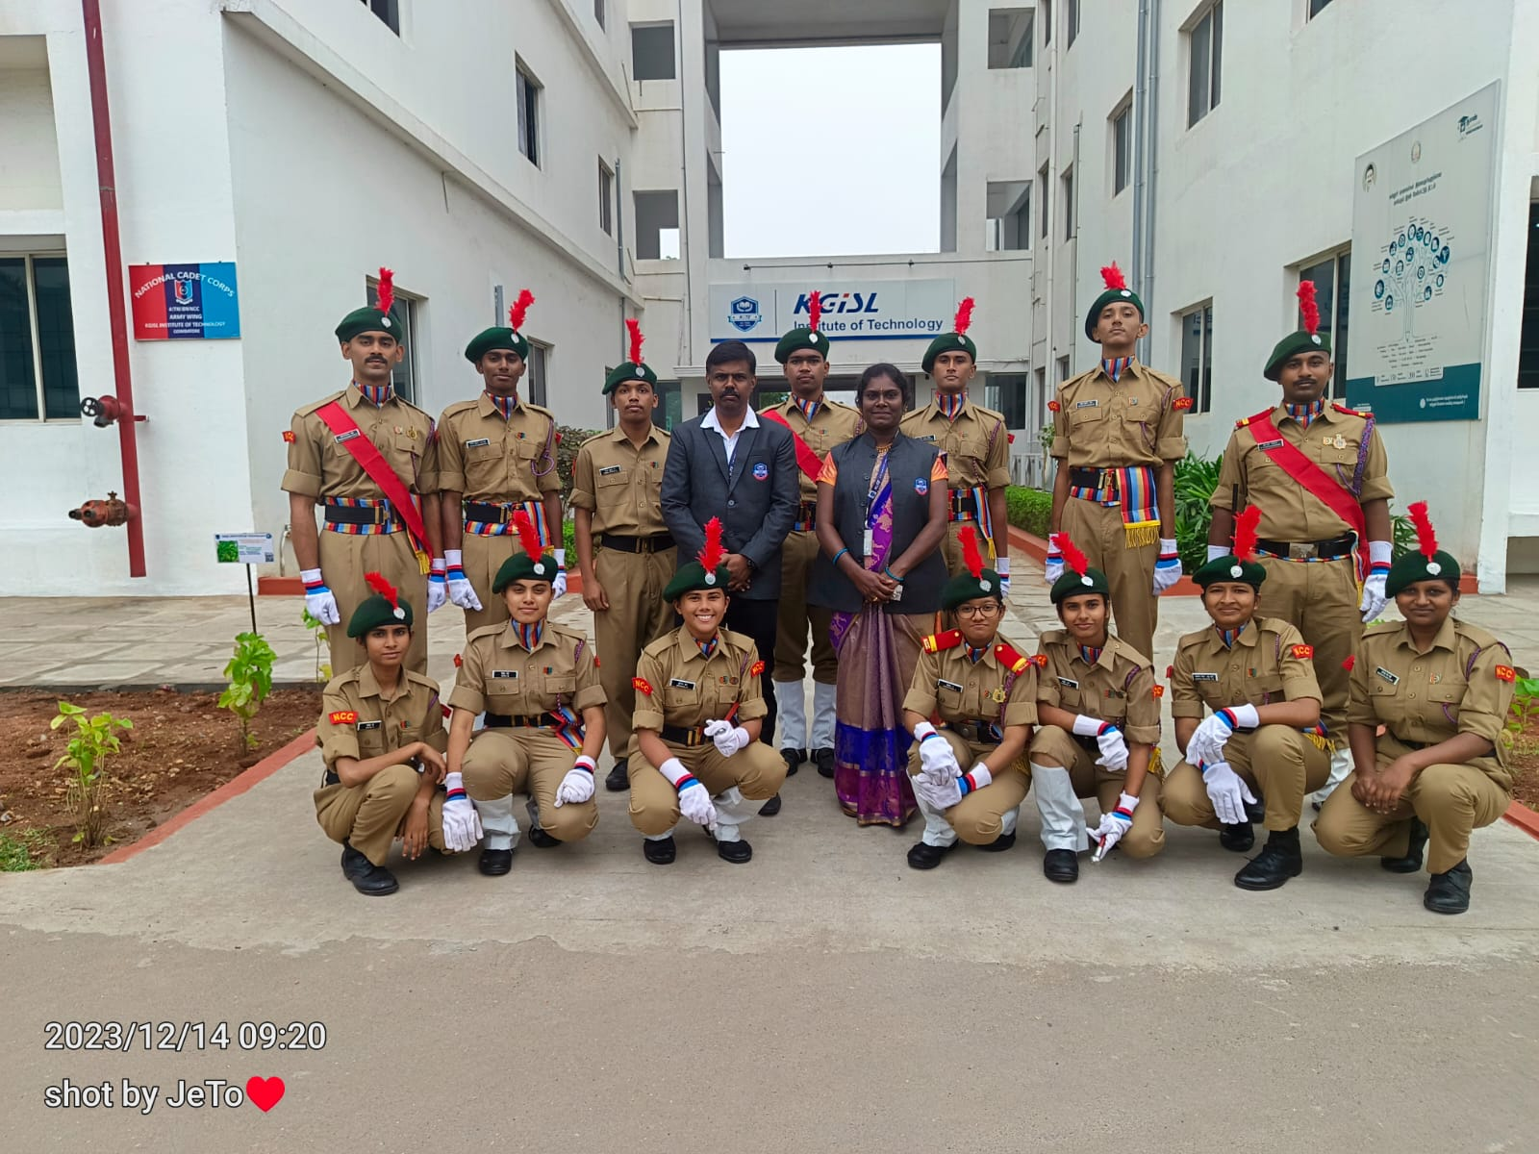
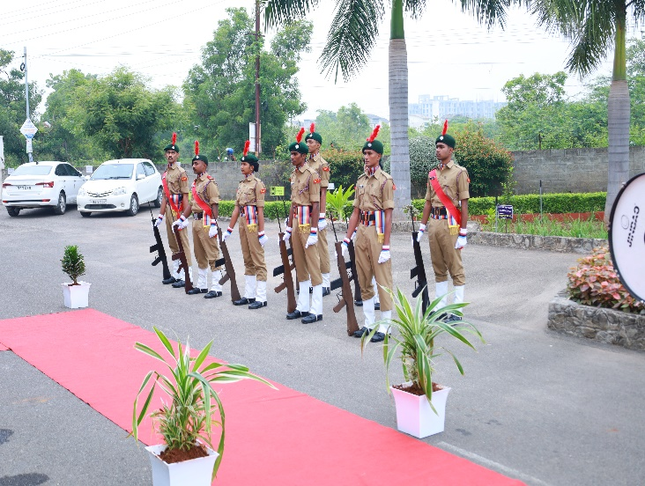
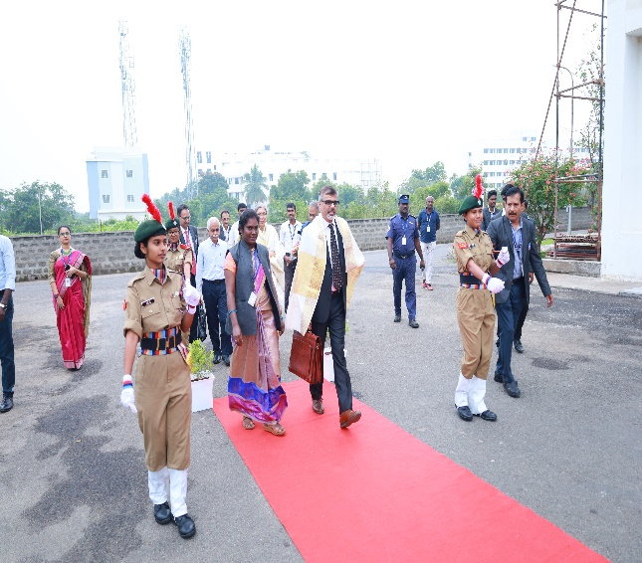
The NCC cadets of our institution rendered the Guard of Honour during the NAAC Peer Team Visit held on 13th and 14th December 2023. A contingent of smartly turned-out cadets, both boys and girls, participated in the ceremonial honour at the main entrance and key locations within the campus.
The cadets welcomed the NAAC Peer Team with a disciplined and well-coordinated Guard of Honour, reflecting the core values of NCC—discipline, commitment, and leadership. Their participation significantly contributed to creating a positive and professional impression during the assessment. The ceremonial welcome took place at the entrance of the college and was attended by the Principal, Director, Secretary, AO, ANO, faculty members, non-teaching staff, and students. The NAAC Peer Team appreciated the professionalism and spirit showcased during the event.

The cadets were appreciated by college authorities and NAAC team members for their outstanding turnout, punctuality, and display of ceremonial etiquette.
REPUBLIC DAY on 26.01.24
National Cadet Corps gearing up for Republic Day celebrations which will be held in KGISL Campus, Saravanampatti on 26th January 2024. “NCC Cadets said they arrived early in the morning to participate in the parade to put their best food forward on Republic Day. NCC is providing them with all facilities including hostel facilities as a few cadets come from the remotest areas,” said one of the Cadets. The Chief Guest for the event was Dr. G. Bakthavathsalam, Chairman, KG Hospital included our Secretary, Principal, Director, All HODs, PDs and CTO.Mrs.P.Antony Anaiya, PI-NCC Mr.T.Pradeep Kumar.We looked at the rising flag and saluted it with full hope.
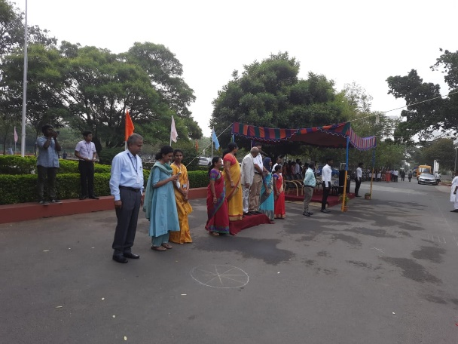
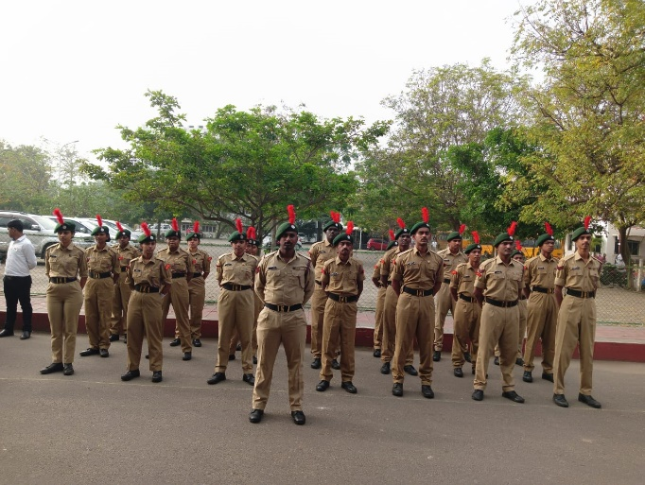
NCC SYMPOSIUM “UTSHAA UDGAM-2K24 ” on 15.03.2024
The NCC unit of [Your Institution Name] successfully organized a one-day symposium titled “UTSHAA UDGAM–2K24” on 15th March 2024. The event aimed to foster leadership, discipline, and awareness among cadets on national and social issues. Various sessions, including Singing (Solo), Dance (Solo),Sports (SD/SW),Drawing, Instrumental, Drill (team comprising of 10 cadets), Singing (Group) (4 to 6 per team), Dance (Group) (4 – 6 per team), Mime (4 – 6 per team), Tent pitching (4 – 6 per team) were conducted, The objective of this symposium is to provide a platform for knowledge sharing, leadership development, and skill enhancement among NCC cadets.
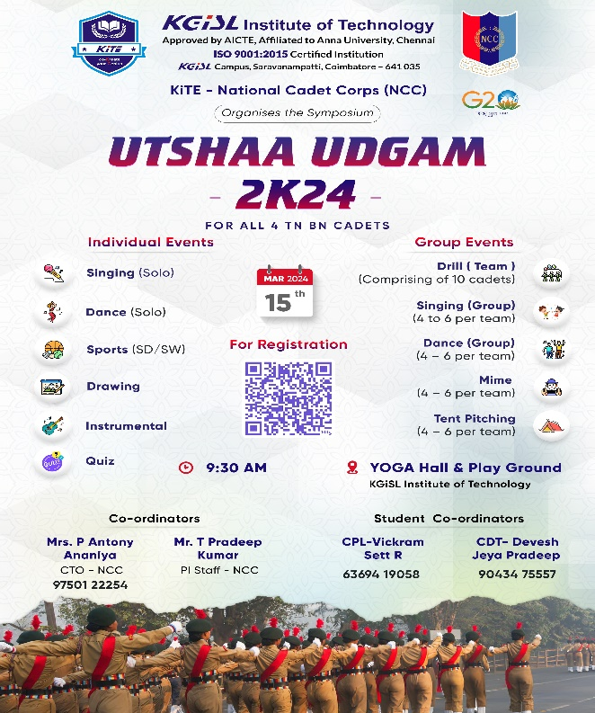
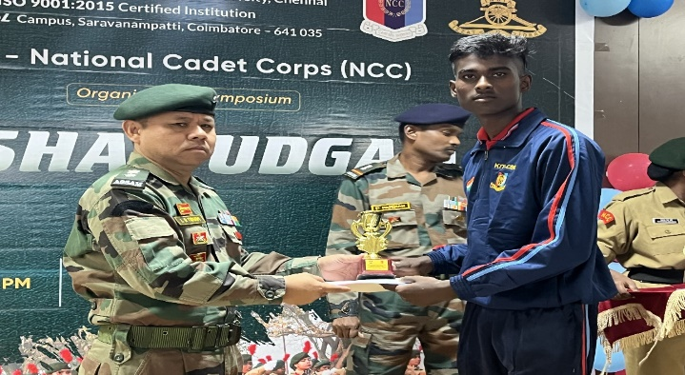
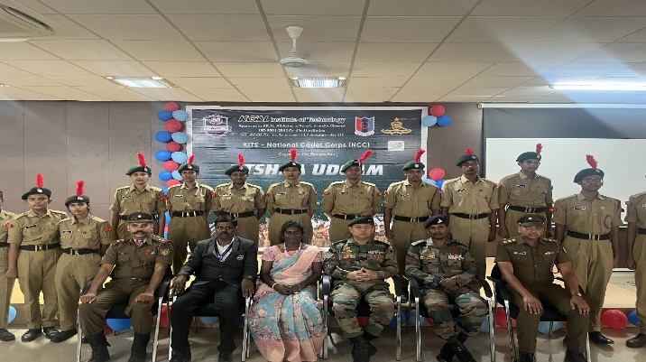
The symposium witnessed active participation from NCC cadets across different institutions, totally 180 cadets are participating in this event. Finally the chief guest Lt.Col. Lalremruata Oinam and Sub.Maj.Pandian interact with cadets to creating a platform for knowledge exchange and team spirit. The event concluded with a valedictory function where winners were awarded, and participants were appreciated for their enthusiasm and discipline. The symposium was a great success and reflected the true spirit of the National Cadet Corps.
DEFENCE CAREER EXPO 2024 on 19.03.2024 to 20.03.24
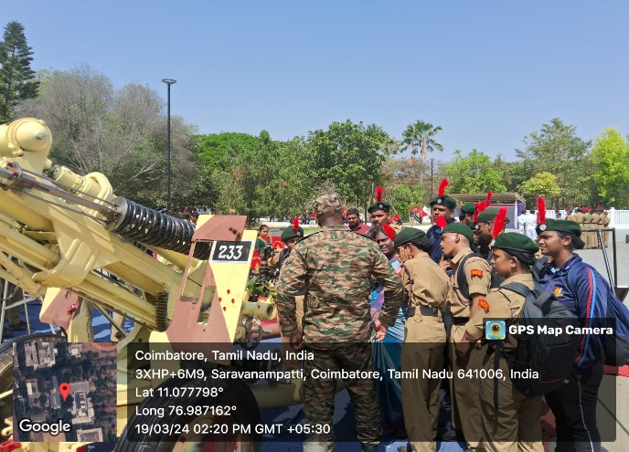
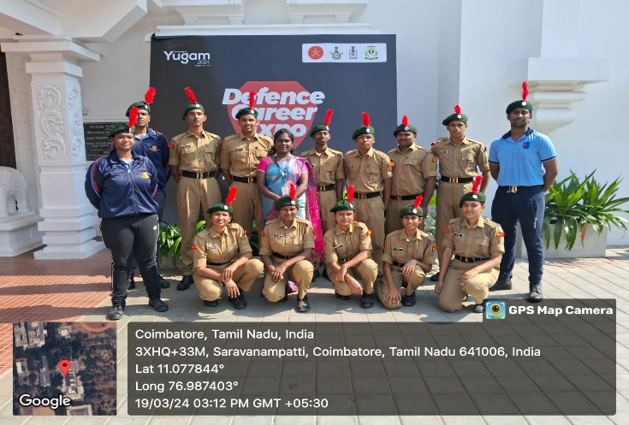
The NCC KiTE, cadets actively participate the “DEFENCE CAREER EXPO 2024” on 19.03.2024 to 20.03.24 held at Kumaraguru college of Technology with the objective to serve as a comprehensive platform for job seekers, recent graduates, and seasoned professionals interested in learning from defence officers and understanding the multifaceted roles within the defence sector.
The two day long expo was inaugurated by Col BVS Shiva Rao, Group Commander, NCC Group HQ Coimbatore. Lt Gen Hari Mohan Iyer, AVSM. Commandant, School of Artillery, Deolali delivered special address by recalling his life journey in the Armed Forces and motivated cadets to join the forces saying that it offers one of the most adventurous life. Col CST Swamy, Administrative officer, NCC Group HQ Coimbatore oriented students on the career opportunities in the Armed Forces.
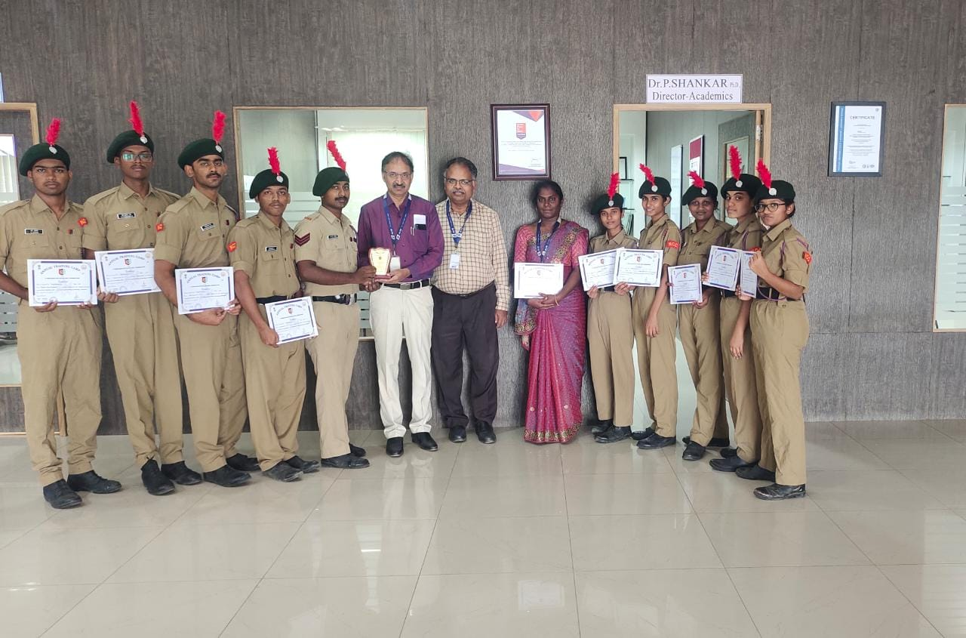
ANNUAL TRAINING CAMP
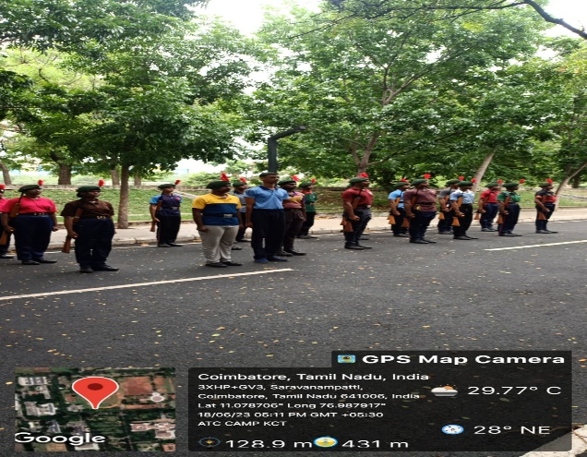
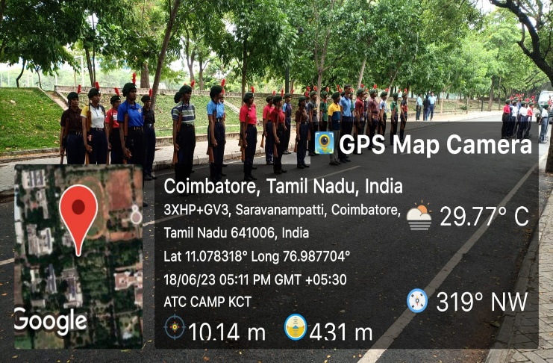
A total of 19 cadets attended the Combined Annual Training Camp (CATC) held at KCT, Coimbatore. During the camp, they gained valuable insights about the C-Certificate examination conducted at PSG, Coimbatore on 17.02.2024 to 18.02.2024, and the B-Certificate examination held at PSGR, Coimbatore on 23.03.2024 to 24.03.2024. As a result, 15 cadets successfully cleared the B-Certificate exam, and 4 cadets were awarded the C-Certificate this year.

KITE SPORTS DAY
NCC cadets are participated the KITE Sports Day on 11.04.24.
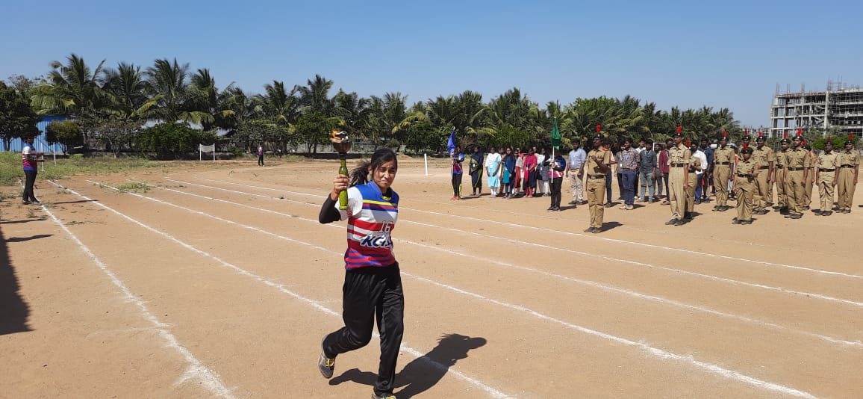
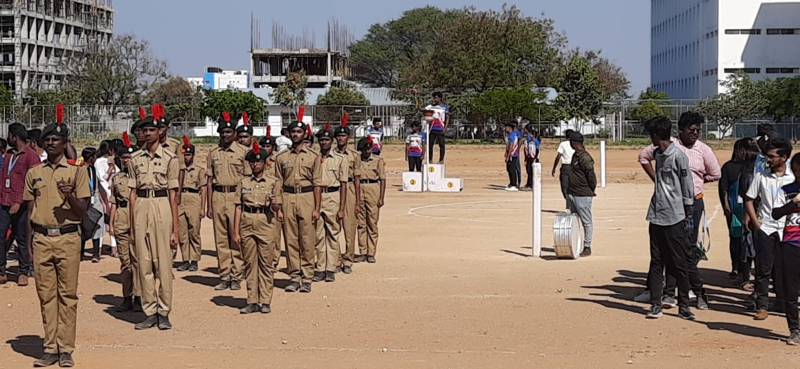

NCC ACHIEVEMENTS AND RECOGNITION
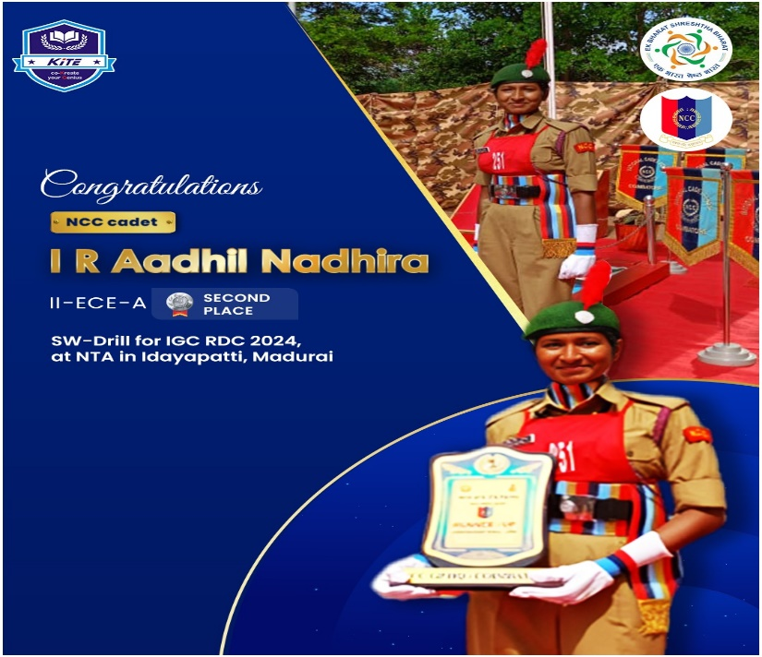
Cad.AADHIL NADHIRA –II-ECE got Second place in SW-drill for IGC RDC-24 at NTA in Idayapatti, Madurai

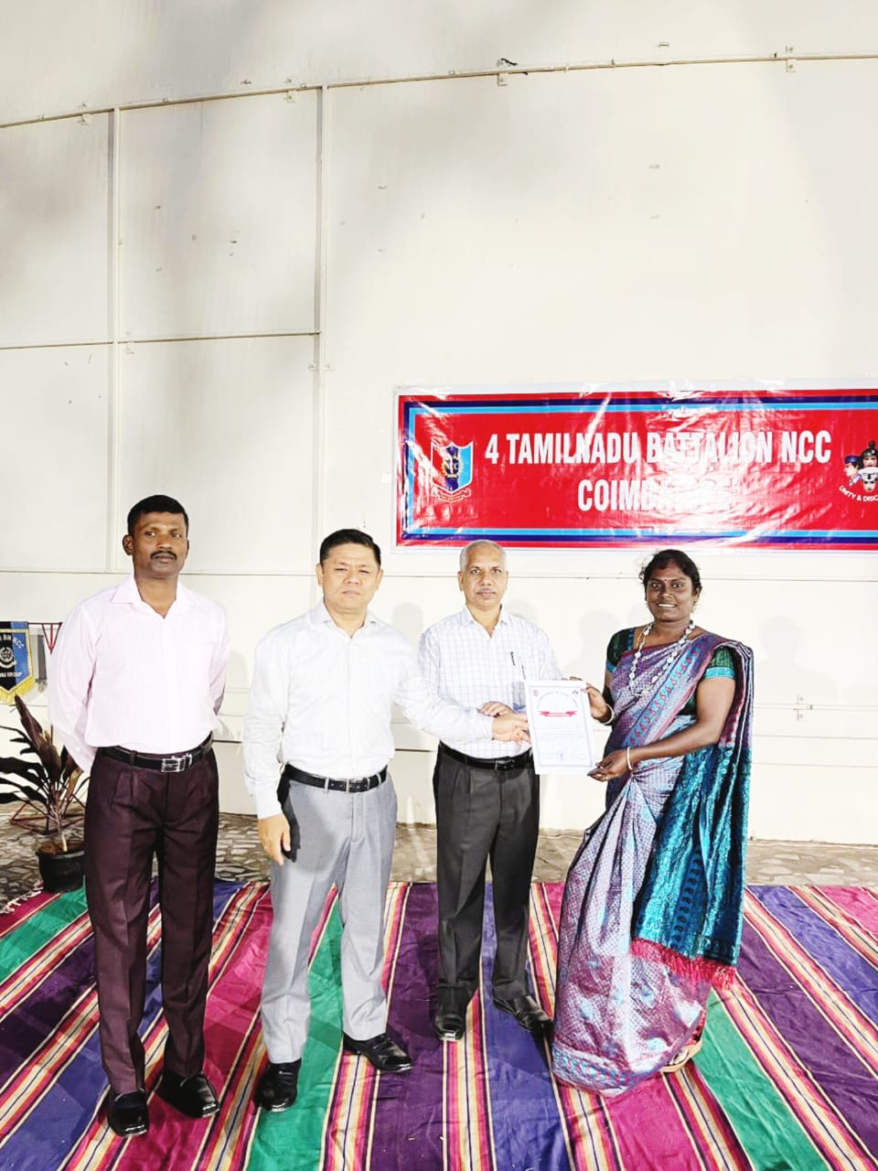
A Special recognition to our KiTE NCC,4 TN BN commending office Col.Lalremruata Oynam and Sub.major M.Pandiyan Sir.

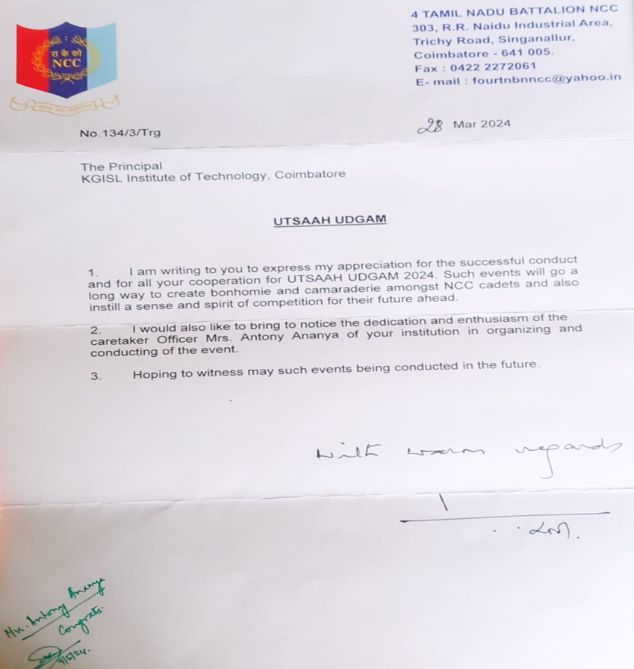

Appreciation letter to receive by our 4 TN BN to conduct UTSHAA UDGAM symposium.

