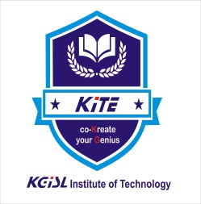

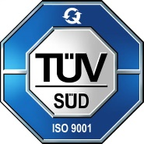
KGISL INSTITUTE OF TECHNOLOGY
(An Autonomous Institution)
(Affiliated to Anna University, Chennai, Approved By AICTE, New Delhi
Recognized by UGC, Accredited by NBA (B.Tech-IT,B.E. – CSE, ECE )
# 365, KGiSL Campus, Thudiyalur Road, Saravanampatti, Coimbatore-641035

NATIONAL CADET CORPS (NCC)
ANNUAL REPORT
2024 - 2025

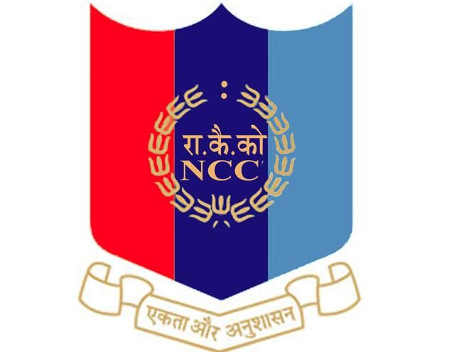

4 TAMIL NADU BATALLIAN NCC, COIMBATORE

INDEPENDENCE DAY 15.08.24

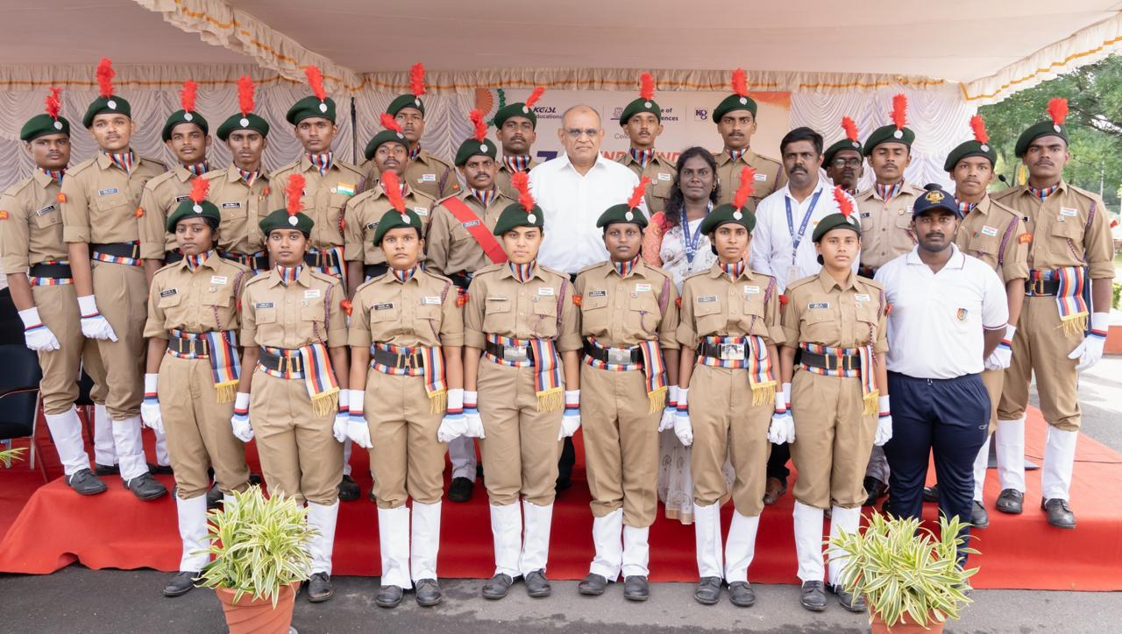
Every year Independence Day celebration is done in our college premises. Being an NCC cadet we must celebrate Independence Day to respect our patriotism. NCC unit of our college plays an important part in Independence Day celebration. NCC cadet have special practice for Independence Day celebration. Piloting for the guests, commanding preparation, band set practices and seniors reporting are the practices done by NCC careers as a preparation of Independence Day.

ENROLMENT on 17.10.24
The notice for NCC enrolment for the academic year 2024–25 was displayed on the notice board on 22.09.2023. As per the directions of Lt. Col. Lalremruata Oinam, Commanding Officer, and Sub. Maj. Pandiyan, 04 (TN) NCC, Coimbatore, both boys and girls from the second year of KITE were considered for first-year NCC enrolment. A total of 45 students from various classes appeared for the enrolment tests, and based on their performance, 12 students were selected and enrolled into the first-year NCC.
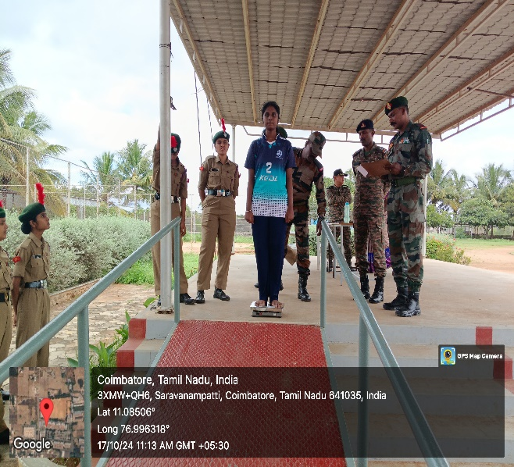
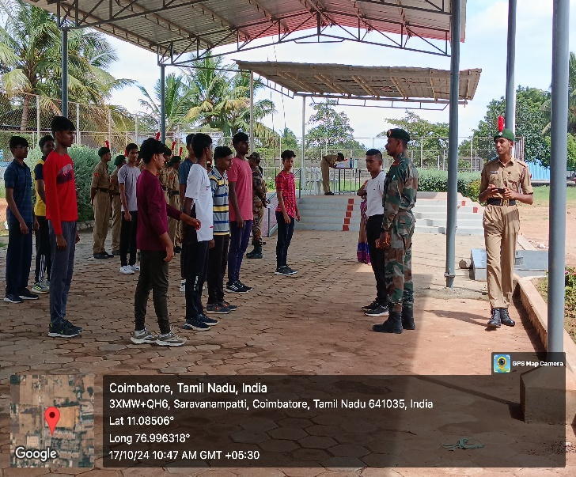
NCC RANK PROMOTION
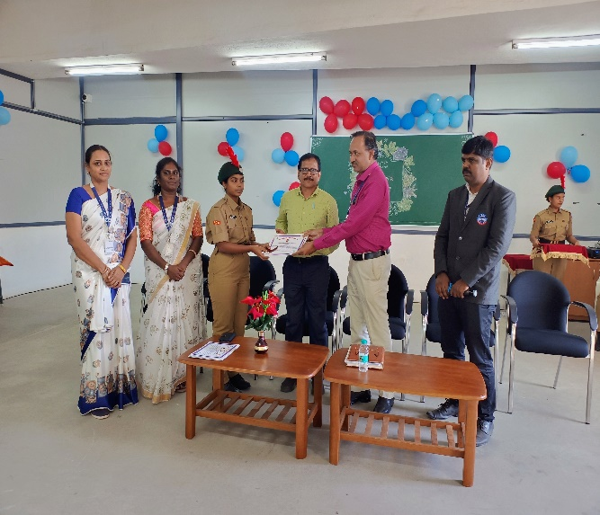
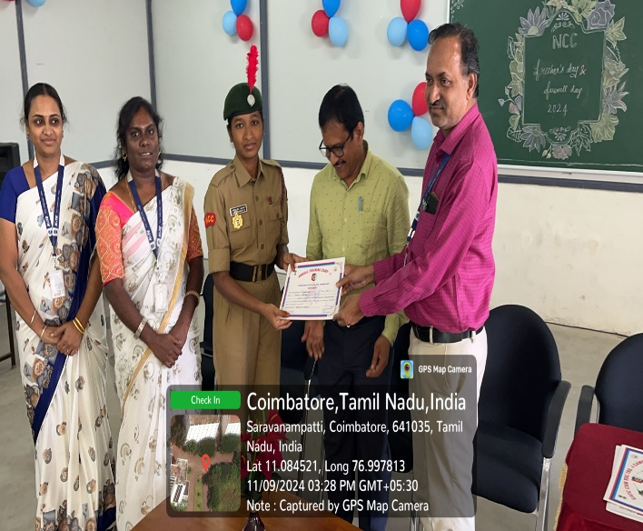
On September 11, 2024 the rank promotion ceremony for the NCC army wing was conducted, wherein Dr. M. Selvam, Principal, KITE was the chief guest and Mr. D. Manikandan, Administrative Officer-KITE & Ex-Army Officer was special guest. Some of the cadets were promoted to higher ranks for their hard-work, and dedication towards the organisation.

NCC Passing the Torch Ceremony on 09.11.24
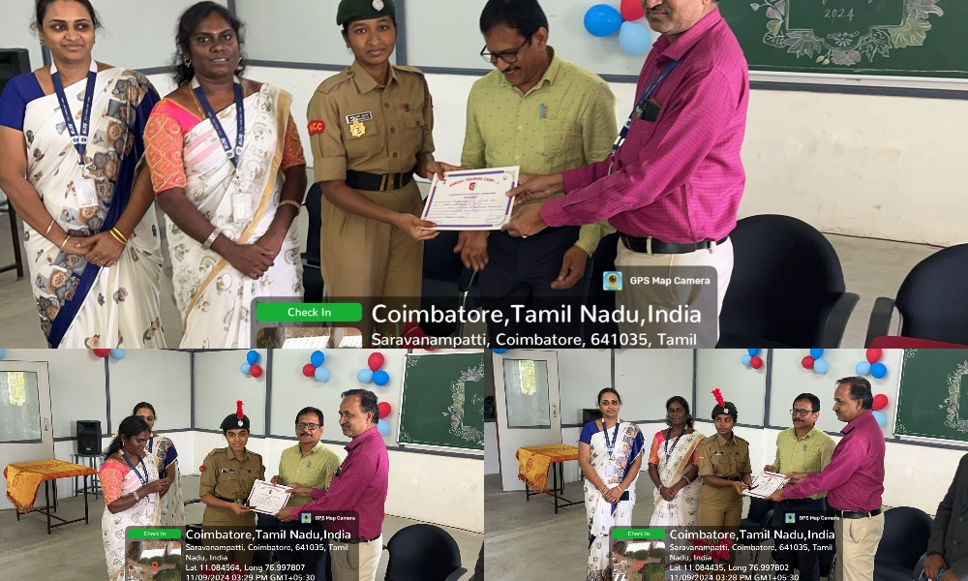
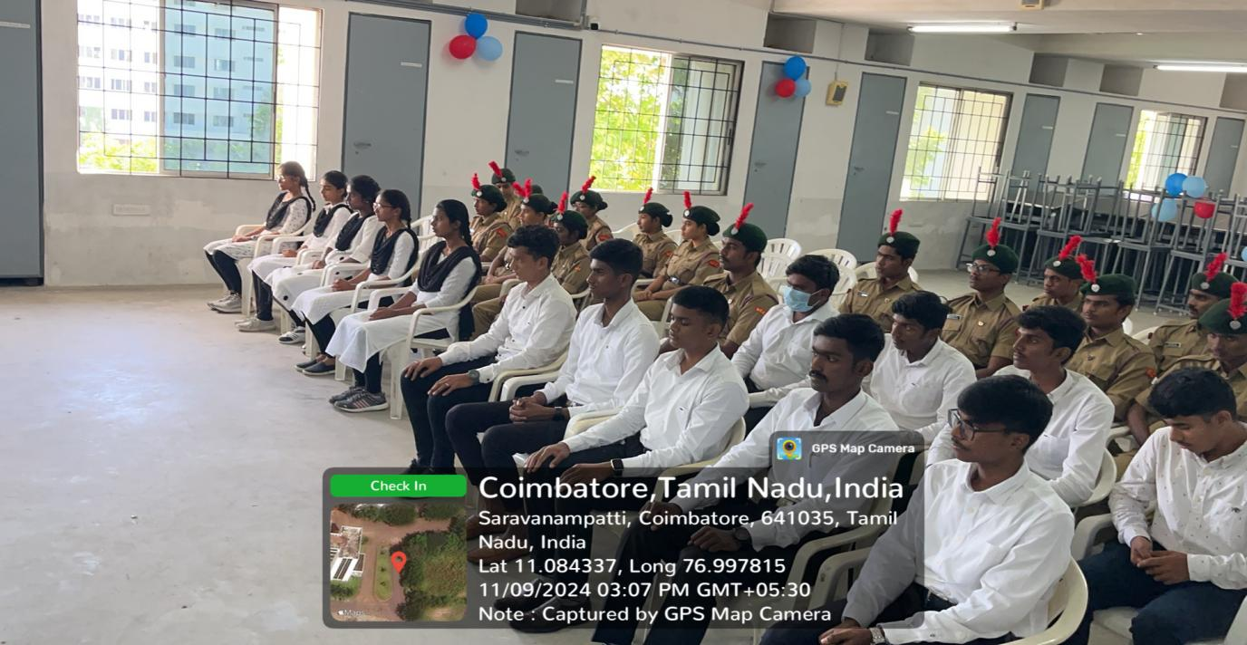
The NCC Passing the Torch Ceremony was conducted on 9th November 2024 to mark the formal transfer of leadership responsibilities from senior cadets to their juniors. The event was held with great pride and discipline at the NCC parade ground in the presence of the ANO, faculty members, and cadets.
Senior cadets symbolically handed over the torch to the newly appointed leaders, signifying the continuation of values such as duty, discipline, and dedication. The ceremony included a short parade, oath-taking by the new leaders, and inspiring speeches by outgoing cadets and NCC officials.

This ceremony not only celebrated the achievements of the outgoing batch but also motivated the next generation of cadets to uphold the honour and legacy of the NCC unit.
SHOOTING TRAINING on 06.12.24
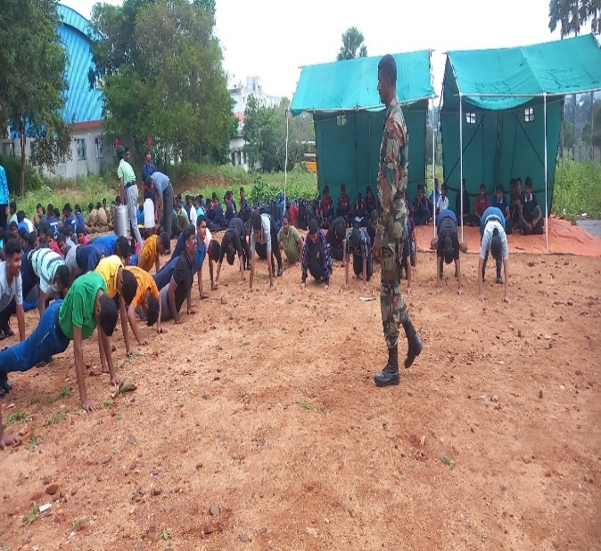
The NCC KiTE, cadets participate the “SHOOTING TRAINING” on 06.12.2024 with the objective Enhance the shooting skills of cadets, focusing on precision, accuracy, and consistency in handling firearms. SM sir and CO Sir also talked about his struggle regarding his career and TSC, RD selection to do more hard work.
REPUBLIC DAY on 26.01.25
National Cadet Corps gearing up for Republic Day celebrations which will be held in KGISL Campus, Saravanampatti on 26th January 2024. “NCC Cadets said they arrived early in the morning to participate in the parade to put their best food forward on Republic Day. NCC is providing them with all facilities including hostel facilities as a few cadets come from the remotest areas,” said one of the Cadets. The Chief Guest for the event was CEO.Aravind, Principal, Director, All HODs, PDs and CTO.Mrs.P.Antony Anaiya, PI-NCC Mr.T.Pradeep Kumar. We looked at the rising flag and saluted it with full hope.
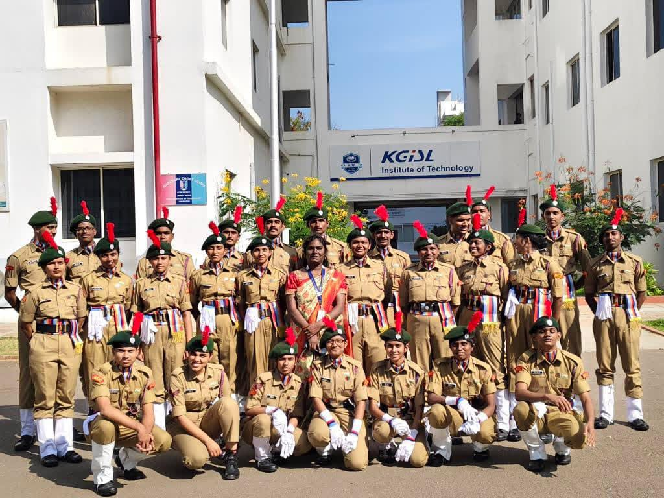
NCC RALLY Say No to Drugs on 08.02.2025
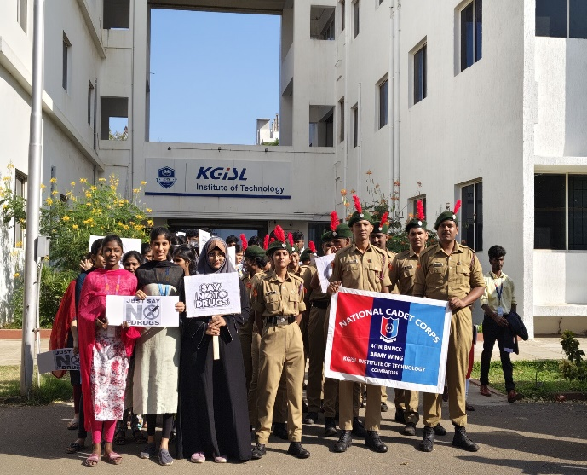
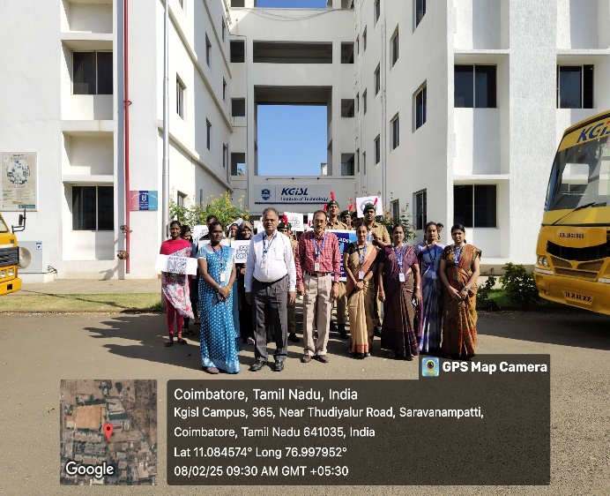
The “Say No to Drugs” Awareness Program was organized on 08th February 2025 by the NCC unit of our institution to educate and sensitize students about the harmful effects of drug abuse. The event aimed to promote a drug-free and healthy lifestyle among youth.
The program featured awareness talks, skits, and poster presentations by NCC cadets emphasizing the physical, mental, and social consequences of drug use. The event also included a pledge ceremony, where all participants vowed to stay away from drugs and support others in doing the same.
The initiative received active participation from students and staff and was appreciated for its impactful message. The event successfully reinforced the importance of making informed and positive life choices.
DEFENCE CAREER EXPO 2024 on 28.02.2025 to 01.03.25
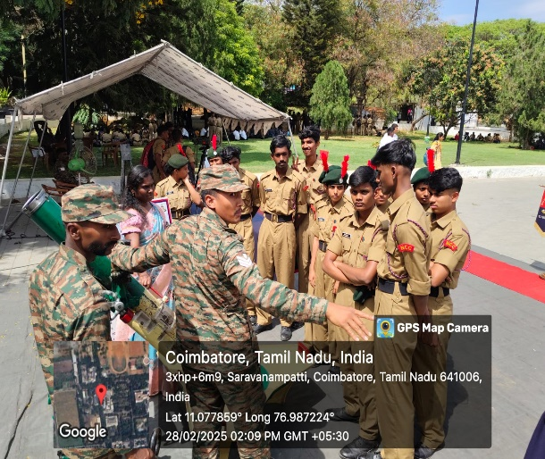
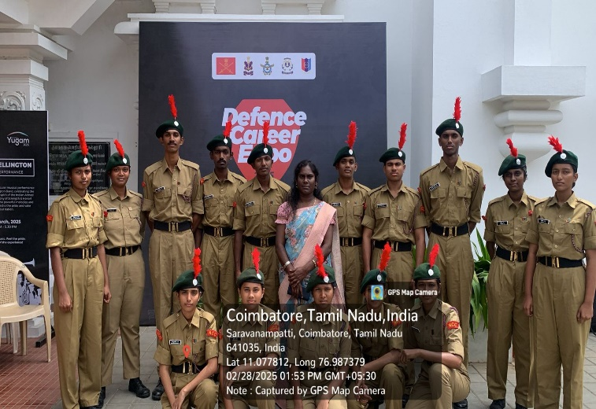
The NCC KiTE, cadets actively participate the “DEFENCE CAREER EXPO 2024” on 19.03.2024 to 20.03.24 held at Kumaraguru college of Technology with the objective to serve as a comprehensive platform for job seekers, recent graduates, and seasoned professionals interested in learning from defence officers and understanding the multifaceted roles within the defence sector.
The two day long expo was inaugurated by Col BVS Shiva Rao, Group Commander, NCC Group HQ Coimbatore. Lt Gen Hari Mohan Iyer, AVSM. Commandant, School of Artillery, Deolali delivered special address by recalling his life journey in the Armed Forces and motivated cadets to join the forces saying that it offers one of the most adventurous life. Col CST Swamy, Administrative officer, NCC Group HQ Coimbatore oriented students on the career opportunities in the Armed Forces.

NCC SYMPOSIUM “UTSHAA UDGAM-2K24 ” on 11.04.2025
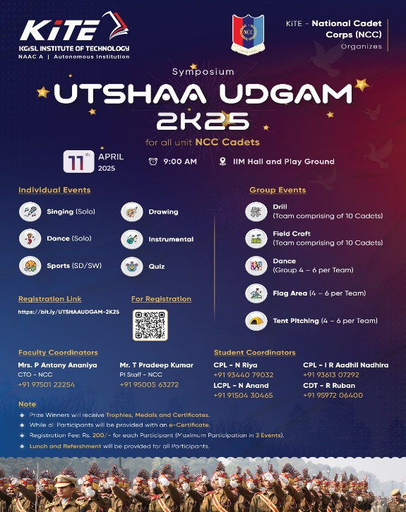
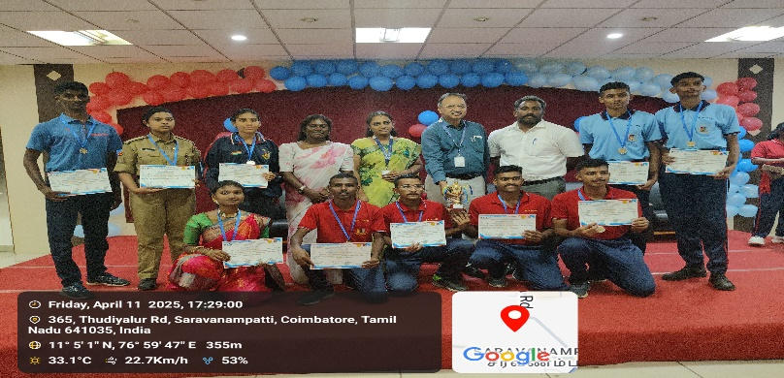
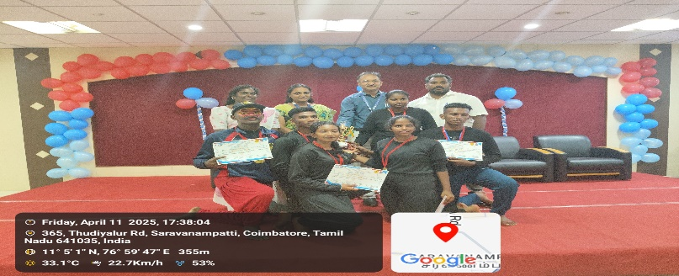
The NCC unit of [Your Institution Name] successfully organized a one-day symposium titled “UTSHAA UDGAM–2K25” on 11th April 2025. The event aimed to foster leadership, discipline, and awareness among cadets on national and social issues. Various sessions, including Singing (Solo), Dance (Solo),Sports (SD/SW),Drawing, Instrumental, Drill (team comprising of 10 cadets), Singing (Group) (4 to 6 per team), Dance (Group) (4 – 6 per team), Mime (4 – 6 per team), FC-BC (4 – 6 per team) were conducted, The objective of this symposium is to provide a platform for knowledge sharing, leadership development, and skill enhancement among NCC cadets.
The symposium witnessed active participation from NCC cadets across different institutions, totally 180 cadets are participating in this event. Finally the chief guest Lt.Col. Lalremruata Oinam and Sub.Maj.Pandian interact with cadets to creating a platform for knowledge exchange and team spirit. The event concluded with a valedictory function where winners were awarded, and participants were appreciated for their enthusiasm and discipline. The symposium was a great success and reflected the true spirit of the National Cadet Corps.
ANNUAL TRAINING CAMP
NCC Cadets Total of 36 cadets attended the Combined Annual Training Camp (CATC) held at KCT, Coimbatore. During the camp, they gained valuable insights about the C-Certificate examination conducted at PSG, Coimbatore on 15.02.2025 to 16.02.2025, and the B-Certificate examination held at PSGR, Coimbatore on 22.02.2025 to 23.02.2025. As a result, 21 cadets successfully cleared the B-Certificate exam, and 15 cadets were awarded the C-Certificate this year.
KITE SPORTS DAY
NCC cadets are participated the KITE Sports Day on 11.04.24.
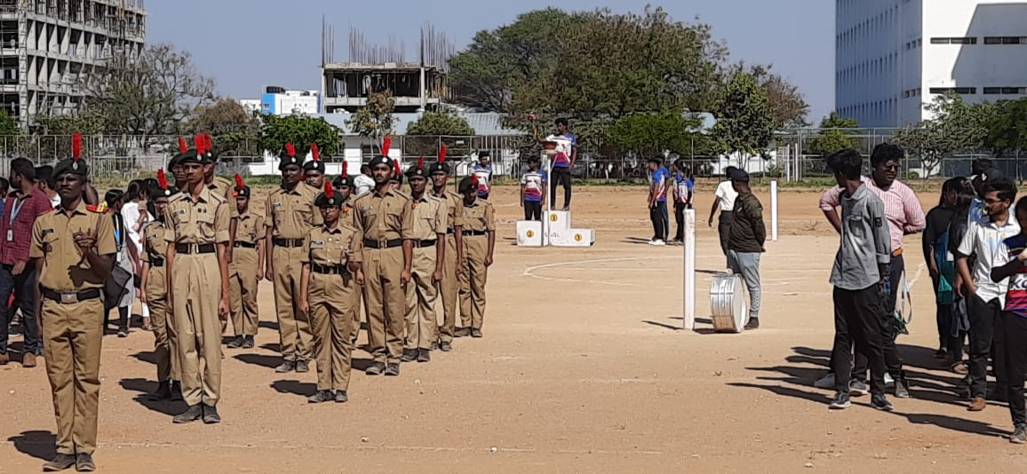
NCC ACHIEVEMENTS AND RECOGNITION
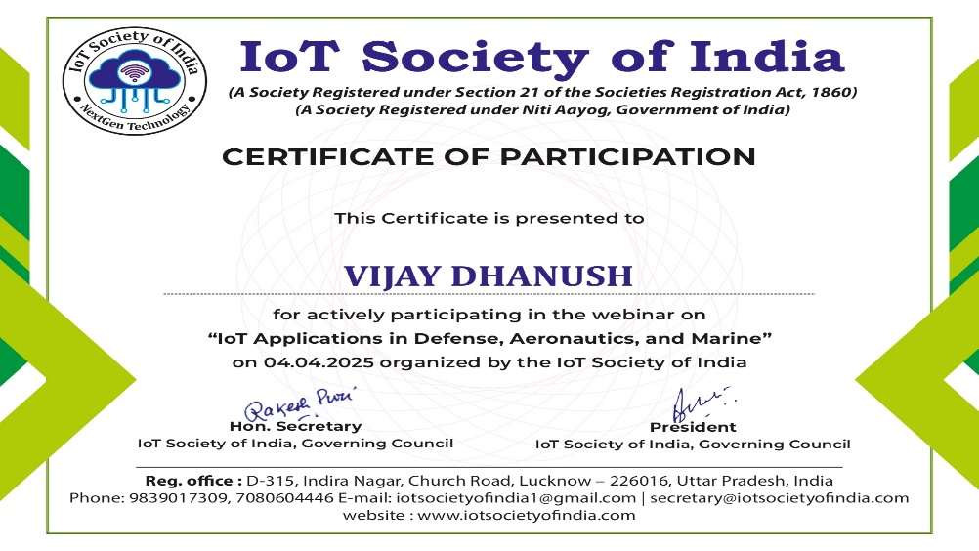
Cat.Vijaya Dhanush participated a webinar on “IoT Applications in Defense, Aeronautics, and Marine” held IoT Society of India on 04.04.25

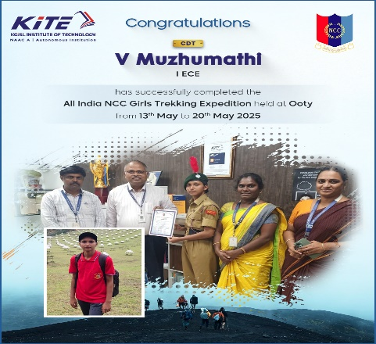
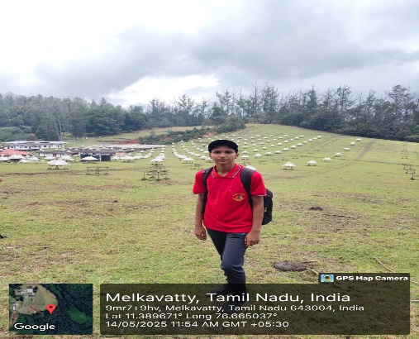
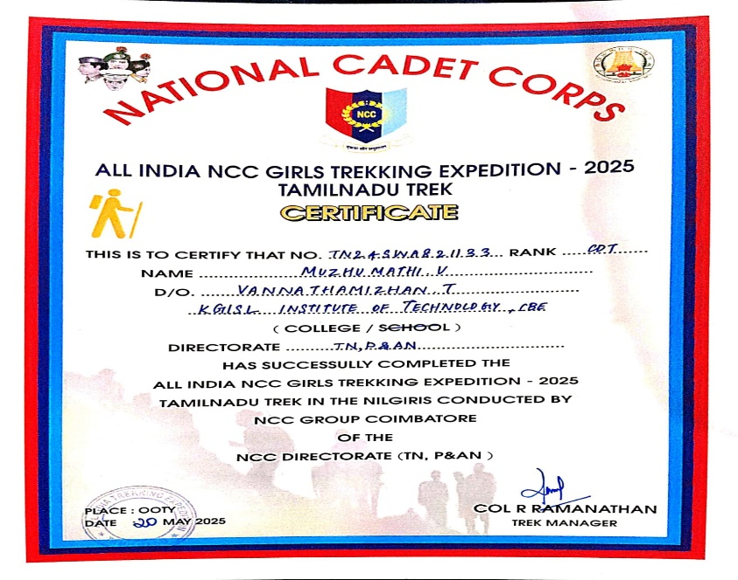

Cdt.V.Muzhumathi
Successfully completed All India NCC Girls Trekking Expedition held at Ooty from 13th May to 20th May 2025

